**Supplementary Materials**

**FDEF: a feature-division ensemble framework for gene regulatory network inference**

Wei Liu, Yu Yang, Li Yang, Xingen Sun, Xiangzheng Fu, Li Peng

1. **Module precision dependency in FDEF**

Although each module has its own workspace, it will inevitably need the information of other modules while dealing with the workspace. Specifically, identifying a gene relation partly depends on other relations, but they may belong to different modules. This cross-module interaction will lead to module precision dependency. That is, the inference precision of a module is dependent on other modules.

Assuming that there is an implementation of FDEF (Figure S1. a) that consists of three modules, and relations , and are in workspaces of modules 1, 2 and 3, respectively. When module 2 is running, it needs to identify whether or not is a positive. If the identification is partly based on the status of , then it is called the forward module precision dependence (Figure S1. b). Similarly, if the identification is partly based on the status of , then it is called the backward module precision dependence (Figure S1. c). Therefore, the ambiguous status of or will possibly affect the identification of .

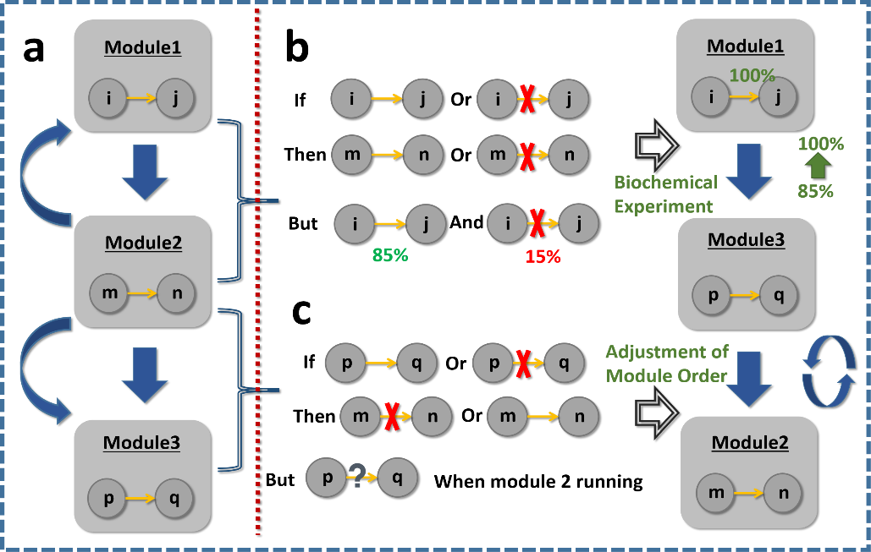

Figure S1. Diagram of module precision dependency. (a) An implementation of FDEF that contains three modules. Arc arrow from module 2 to module 1 stands for forward module precision dependence, and arc arrow from module 2 to module 3 stands for backward module precision dependence; (b) Alleviating module precision dependency by conducting biochemical experiments; (c) Alleviating module precision dependency by adjusting the module order.

For the forward module precision dependence, ambiguous relations (e.g. ) can be accurately corrected by the introduced information from biochemical experiments. Though it cost a lot, we think of them as a success if ambiguous gene relations could be solved with limited experiments. For the backward module precision dependence, an ideal way is to adjust the module order. By doing this, the backward module precision dependence can be transferred into the forward module precision dependence. In this work, the modules are sorted according to its sub-problem task: (1) The construction of the initial network. (2) The elimination of indirect relations. (3) The mining of potential direct relations.

To visualise the module precision dependency, we explored the performance of FDENET without using introduced information. Here, four module orders (1234, 3124, 3214, and 2413) are randomly selected and tested. According to the results in Figures S43-S46, we observed obvious differences, which clearly illustrate that there are dependencies between modules. Last but not least, we also observed that the performance of order 1234 is not the best, which suggests that a further improvement can be made in the future.

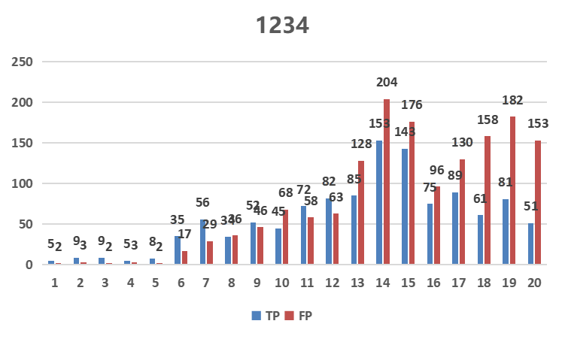

Figure S2. The rebuilt networks in order 1234.

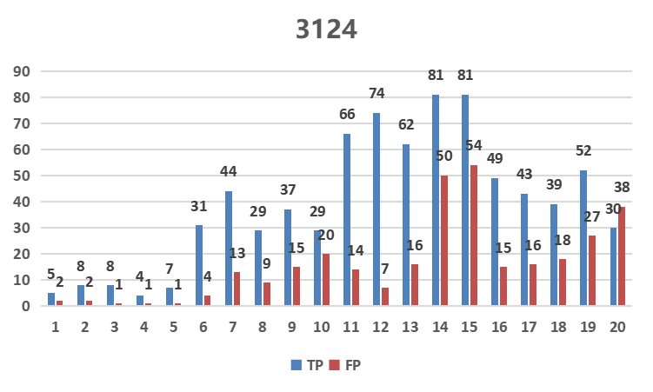

Figure S3. The rebuilt networks in order 3124.

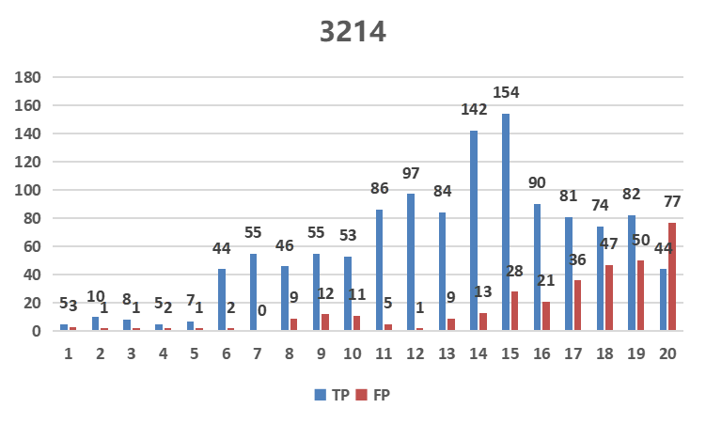

Figure S4. The rebuilt networks in order 3214.

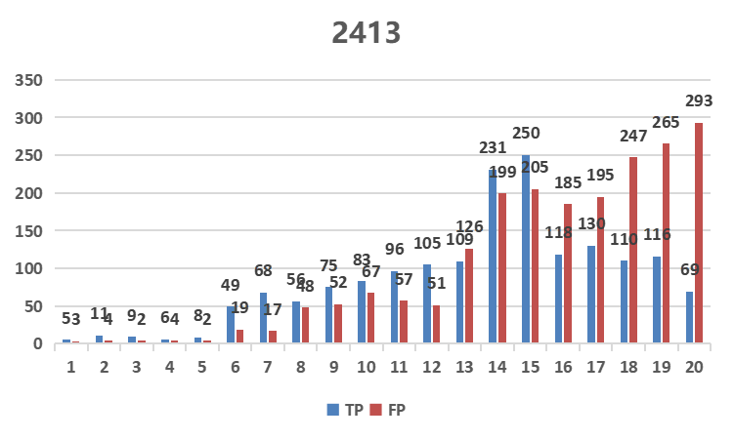

Figure S5. The rebuilt networks in order 2413.

1. **Two examples of the path-rebuilding strategy**

Figure S6 illustrates two examples that the path-rebuilding strategy may have. In the network shown in part a, is a verified indirect relation. Given that the gene 4 is not a regulator after excluding , selecting alternative genes 5 and 7 and rebuilding paths and are unnecessary. In the network shown in part b, is a verified indirect relation, and eliminating this relation does not change the status of gene 4 being a regulator. As the targets of gene 4, genes 1 and 2 are optional nodes for rebuilding the path, but gene 2 is not pivotal because it is not a regulator. On the other side, genes 5 and 6 are known to regulate target gene 3. Therefore, , and are taken into account as alternative relations.

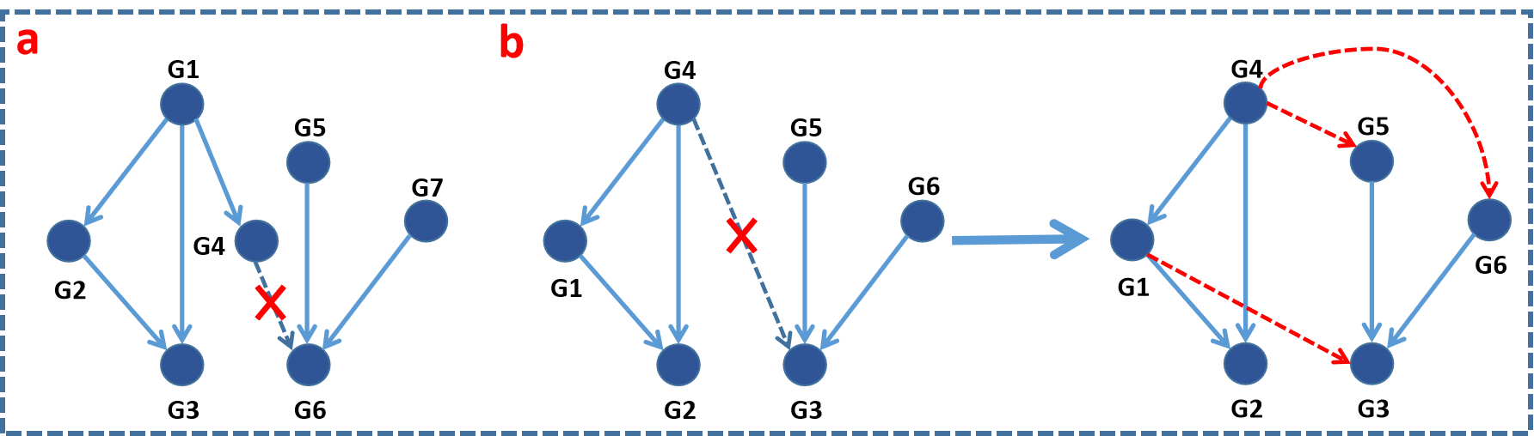

Figure S6. A brief interpretation of the path-rebuilding strategy. (a) Strategy for the non-regulator; (b) Strategy for the regulator.

1. **Comparison between the standard network and the rebuilt network of FDENET on 10-gene networks**

We here exhibited both versions of standard and rebuilt networks of 10-gene networks for more intuitive comparison. The red node in rebuilt networks represents the isolated gene that is non-adjacent to any gene.

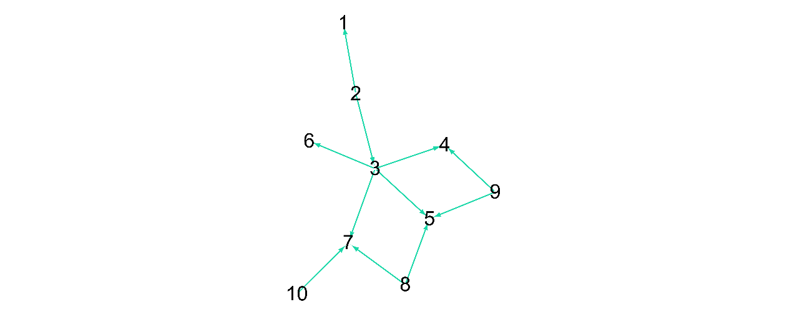

Figure S7. The standard network of DREAM3_10_ Ecoli1.

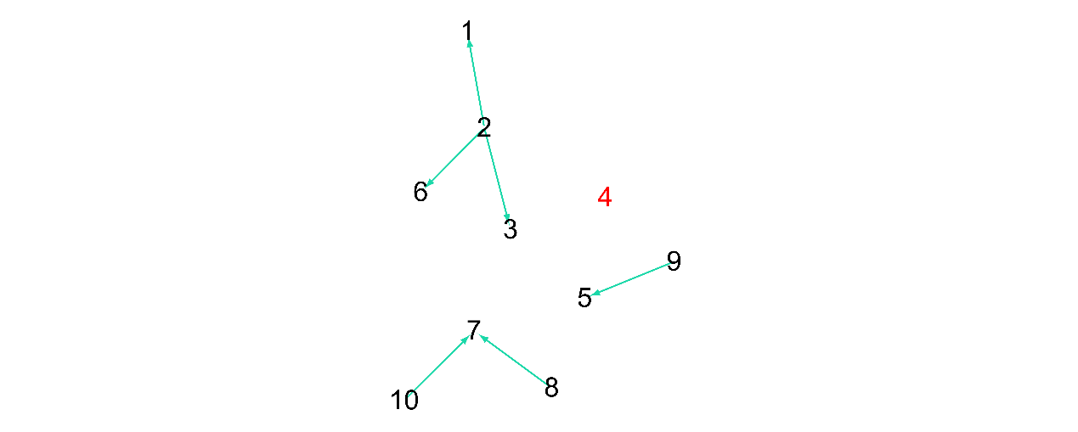

Figure S8. The rebuilt network of DREAM3_10_ Ecoli1.

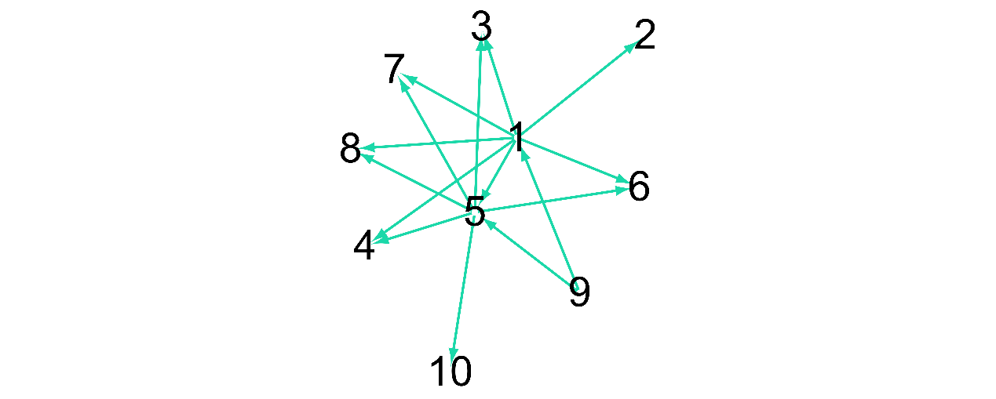

Figure S9. The standard network of DREAM3_10_ Ecoli2.

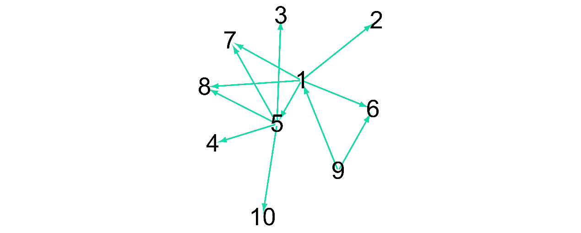

Figure S10. The rebuilt network of DREAM3_10_ Ecoli2.

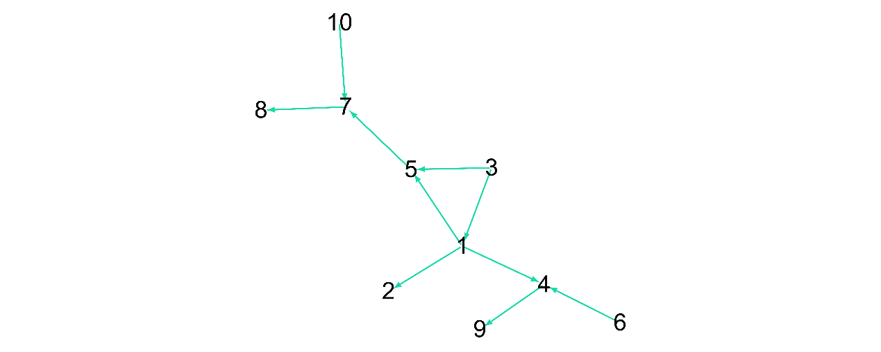

Figure S11. The standard network of DREAM3_10_Yeast1.

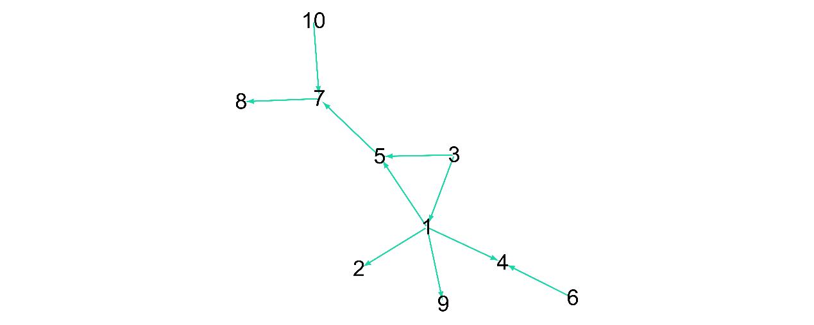

Figure S12. The rebuilt network of DREAM3_10_Yeast1.

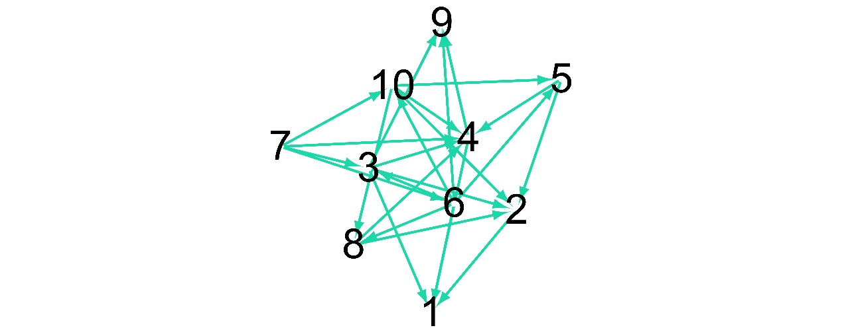

Figure S13. The standard network of DREAM3_10_Yeast2.

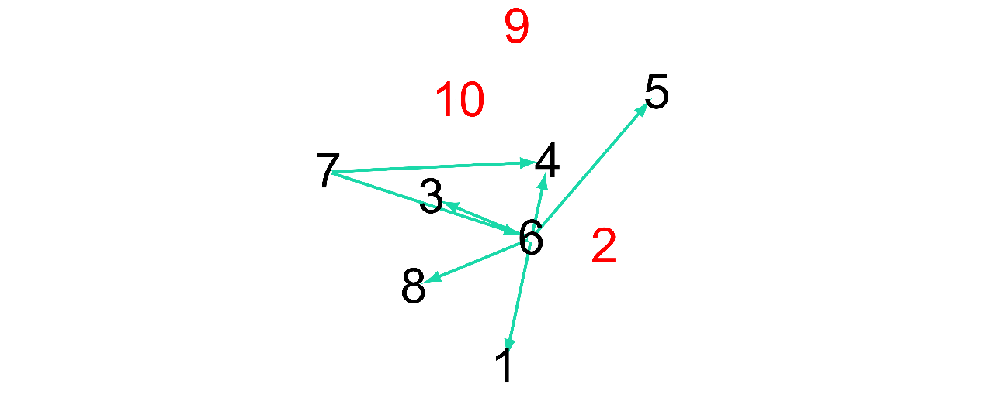

Figure S14. The rebuilt network of DREAM3_10_Yeast2.

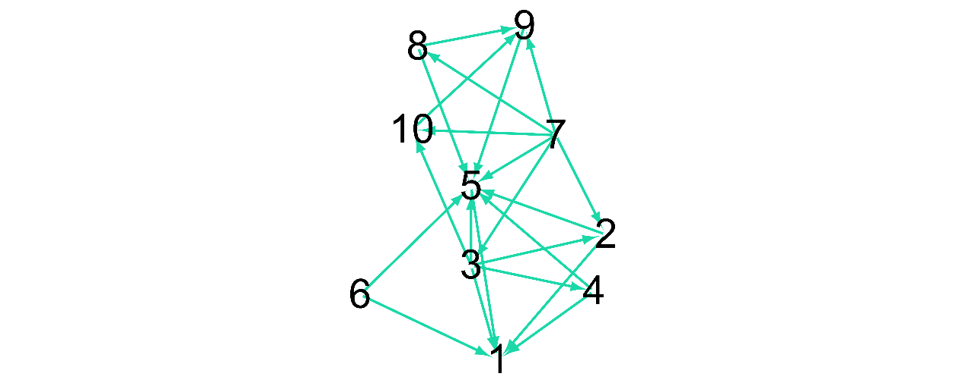

Figure S15. The standard network of DREAM3_10_Yeast3.

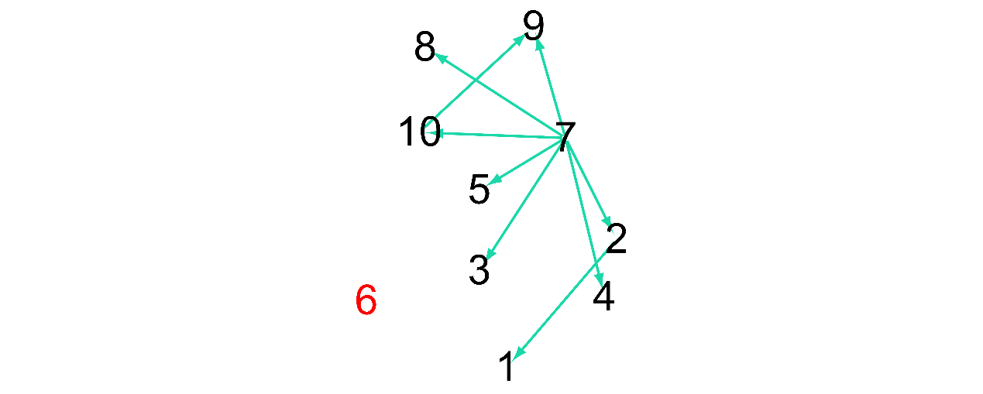

Figure S16. The rebuilt network of DREAM3_10_Yeast3.

1. **Comparison between the standard network and the rebuilt network of FDENET on 50-gene networks**

We here exhibited both versions of standard and rebuilt networks of 50-gene networks for more intuitive comparison. The red node in rebuilt networks represents the isolated gene that is non-adjacent to any gene.

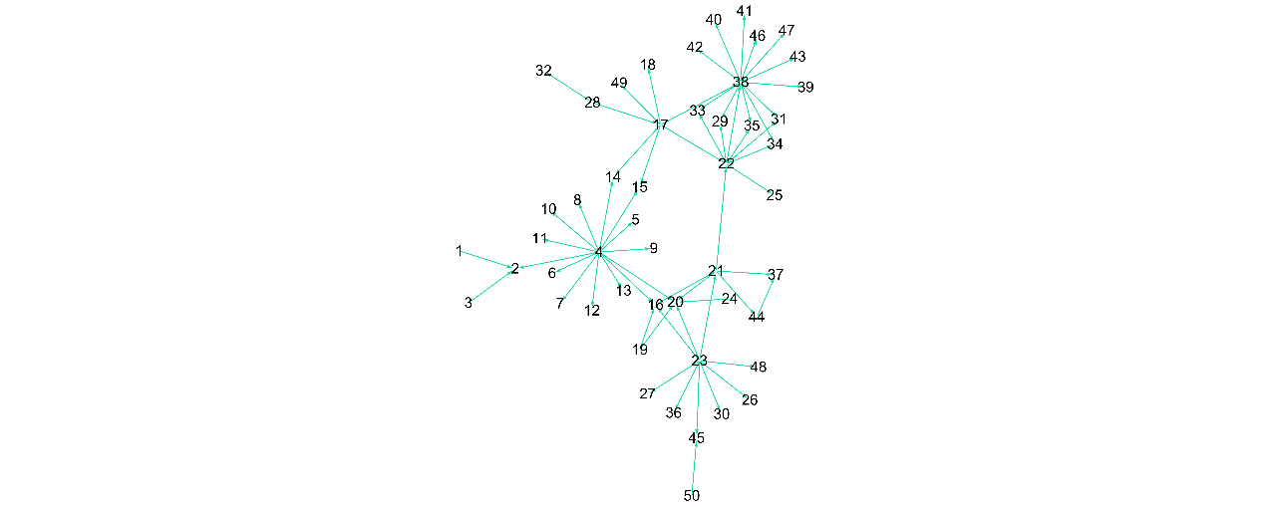

Figure S17. The standard network of DREAM3_50_Ecoli1.

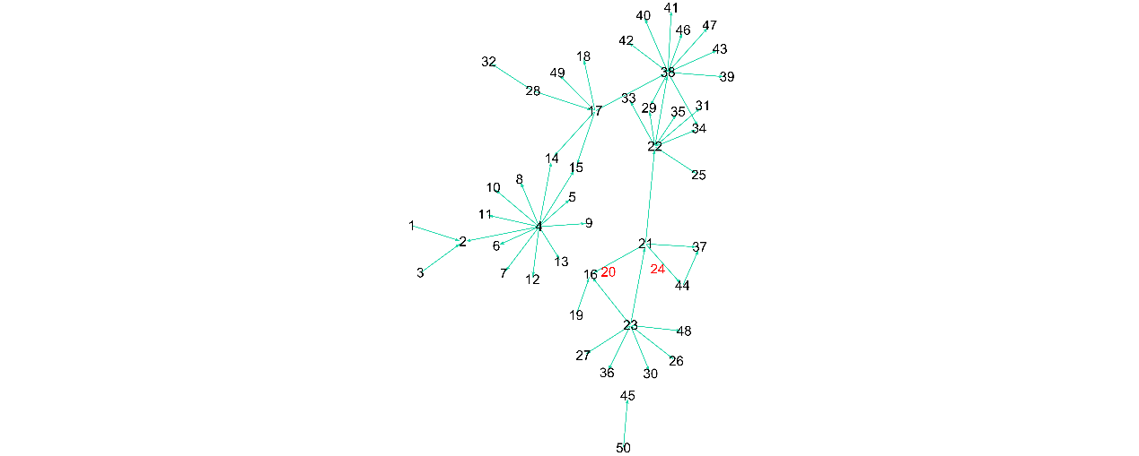

Figure S18. The rebuilt network of DREAM3_50_Ecoli1.

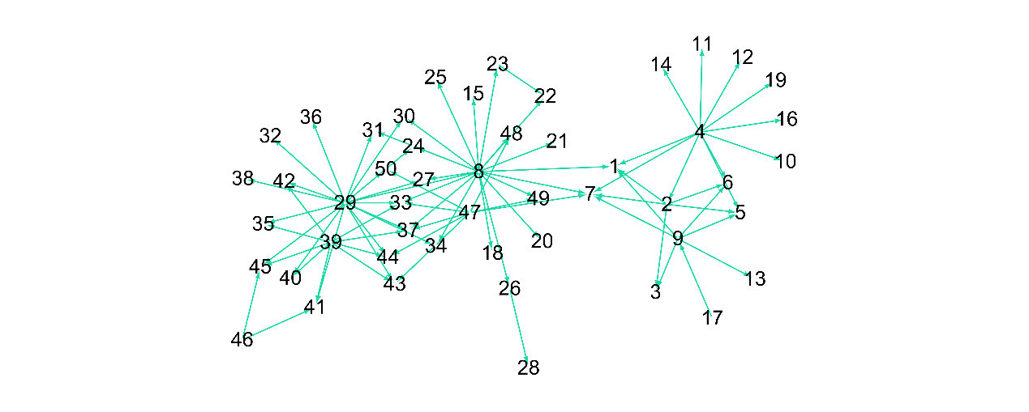

Figure S19. The standard network of DREAM3_50_Ecoli2.

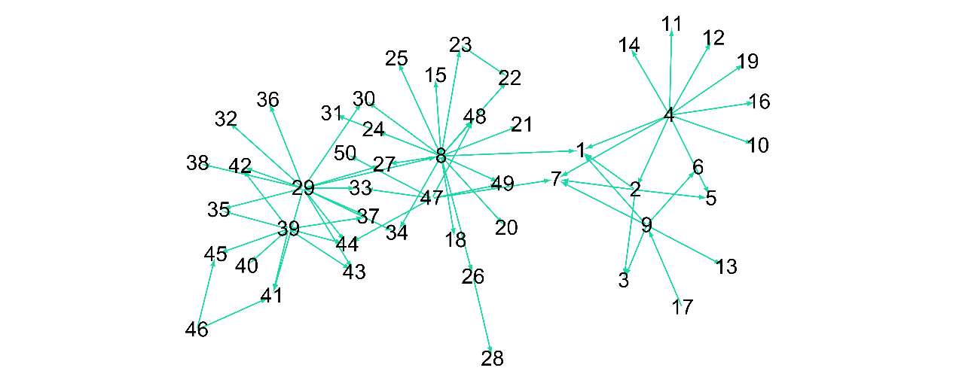

Figure S20. The rebuilt network of DREAM3_50_Ecoli2.

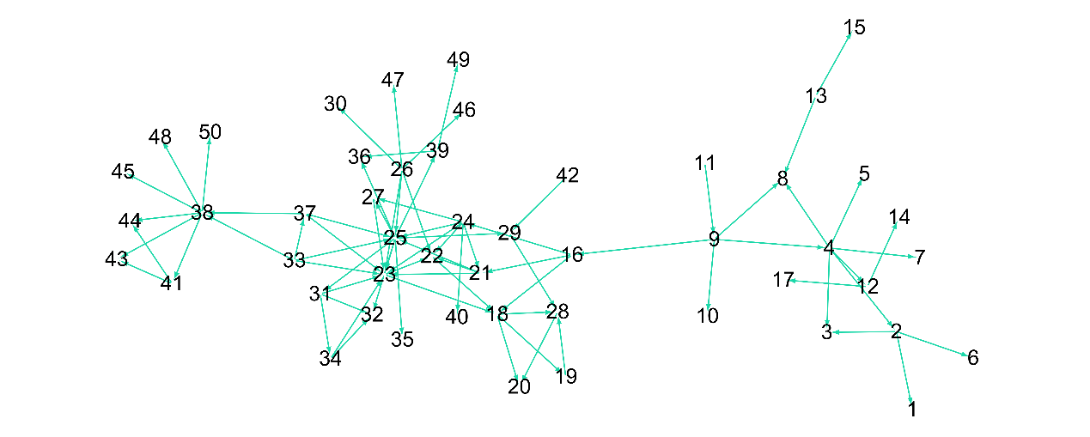

Figure S21. The standard network of DREAM3_50_Yeast1.

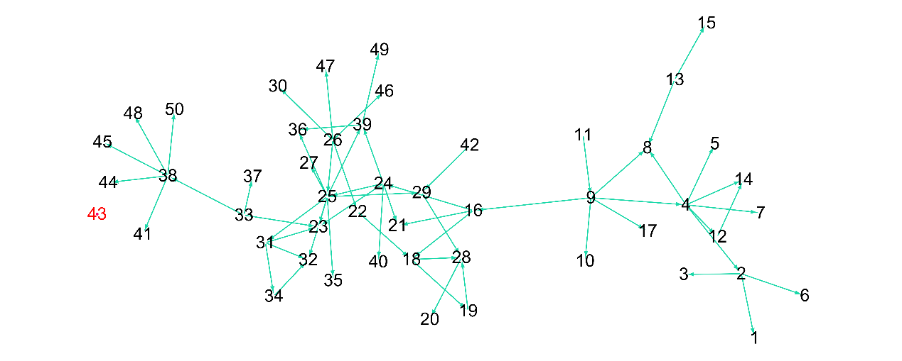

Figure S22. The rebuilt network of DREAM3_50_Yeast1.

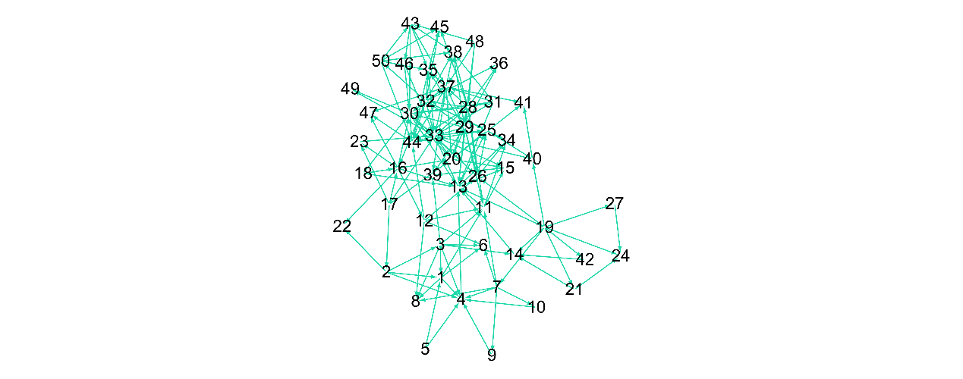

Figure S23. The standard network of DREAM3_50_Yeast2.

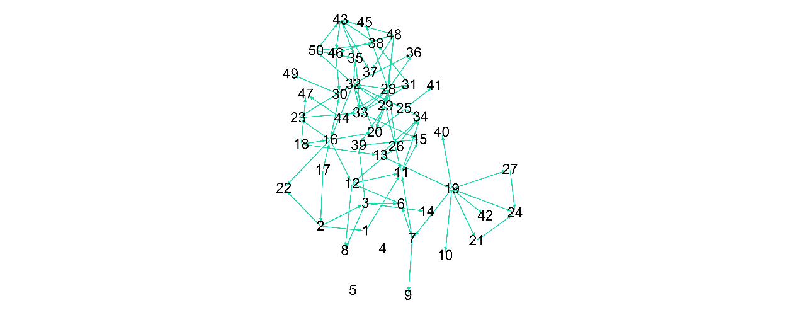

Figure S24. The rebuilt network of DREAM3_50_Yeast2.

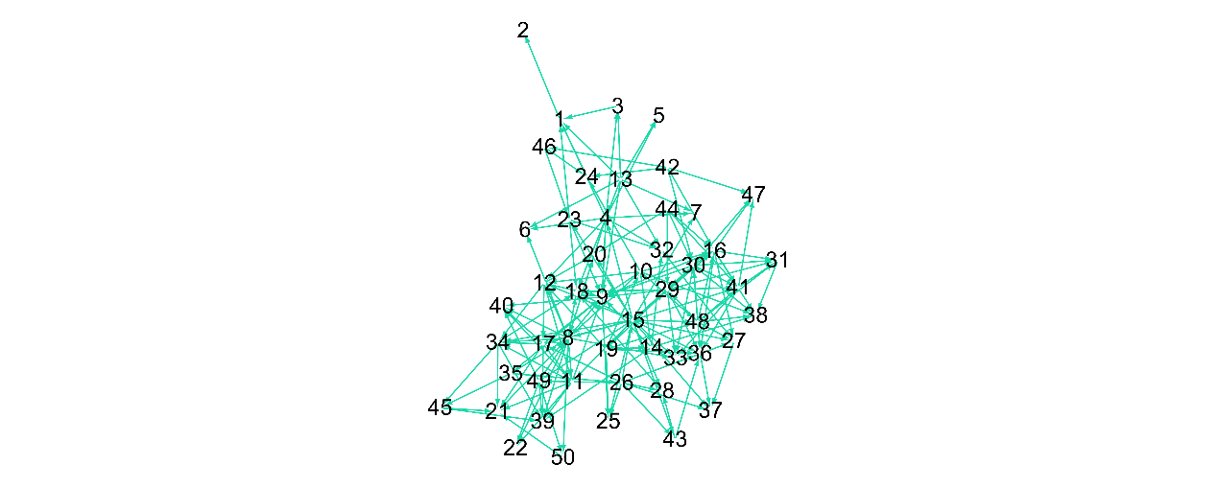

Figure S25. The standard network of DREAM3_50_Yeast3.

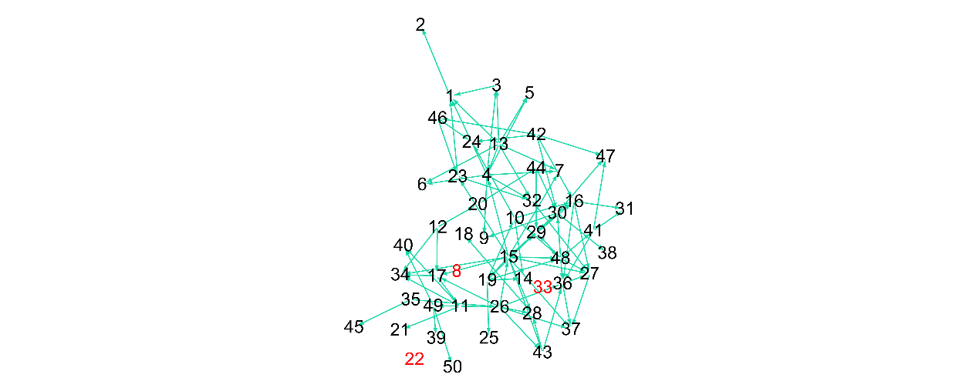

Figure S26. The rebuilt network of DREAM3_50_Yeast3.

1. **Comparison between the standard network and the rebuilt network of FDENET on 100-gene networks**

We here exhibited both versions of standard and rebuilt networks of 100-gene networks for more intuitive comparison. The red node in rebuilt networks represents the isolated gene that is non-adjacent to any gene.

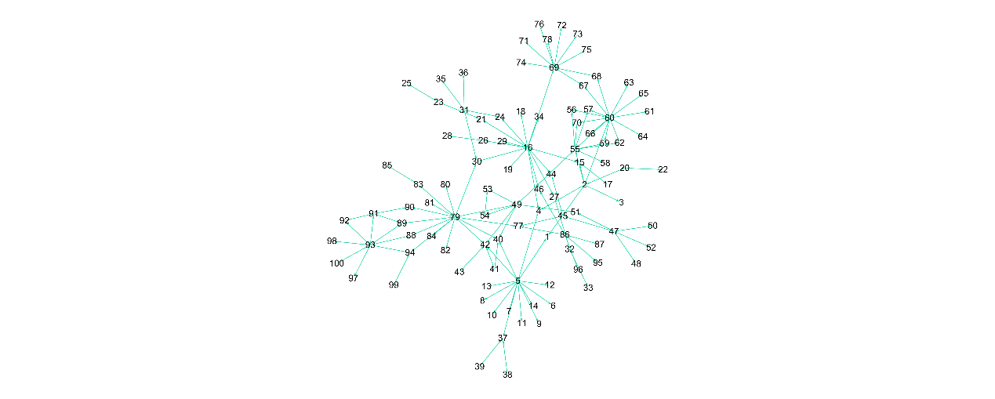

Figure S27. The standard network of DREAM3_100_Ecoli1.

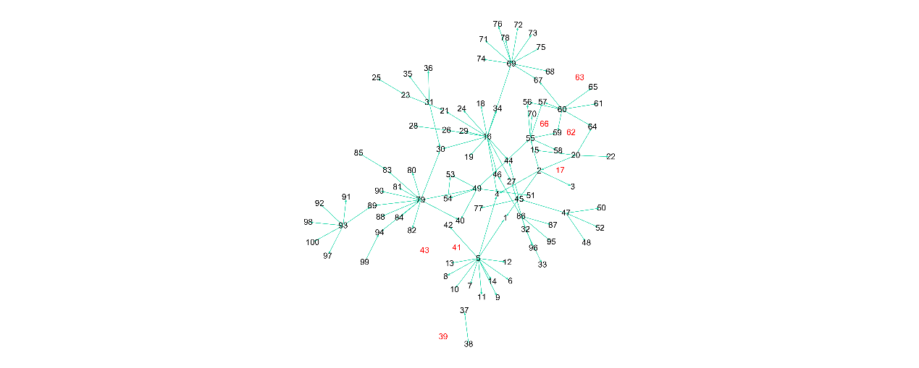

Figure S28. The rebuilt network of DREAM3_100_Ecoli1.

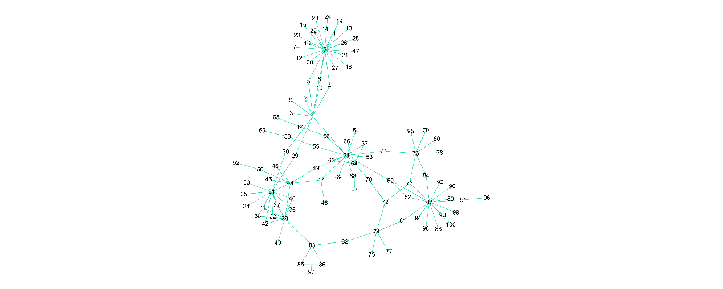

Figure S29. The standard network of DREAM3_100_Ecoli2.

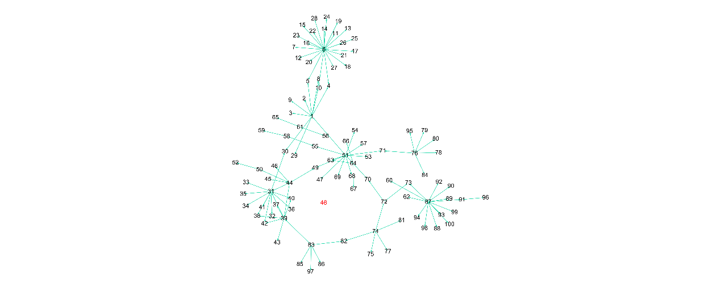

Figure S30. The rebuilt network of DREAM3_100_Ecoli2.

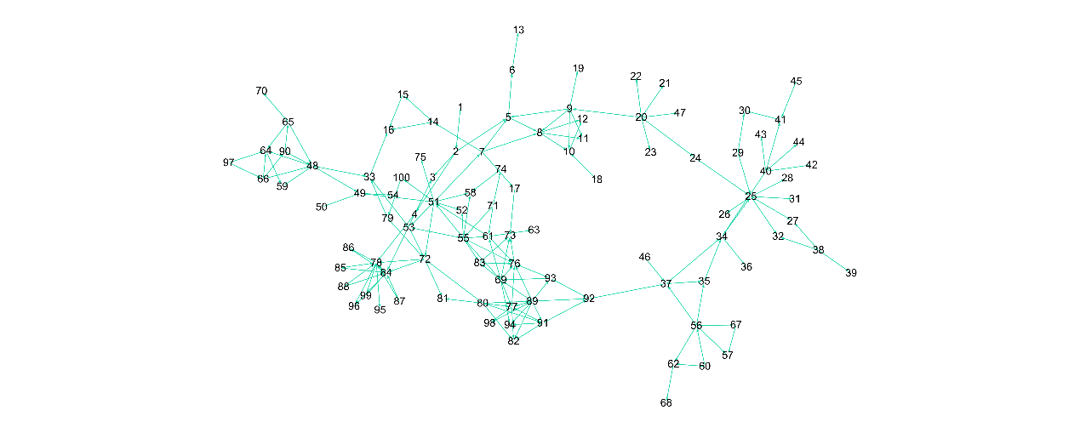

Figure S31. The standard network of DREAM3_100_Yeast1.

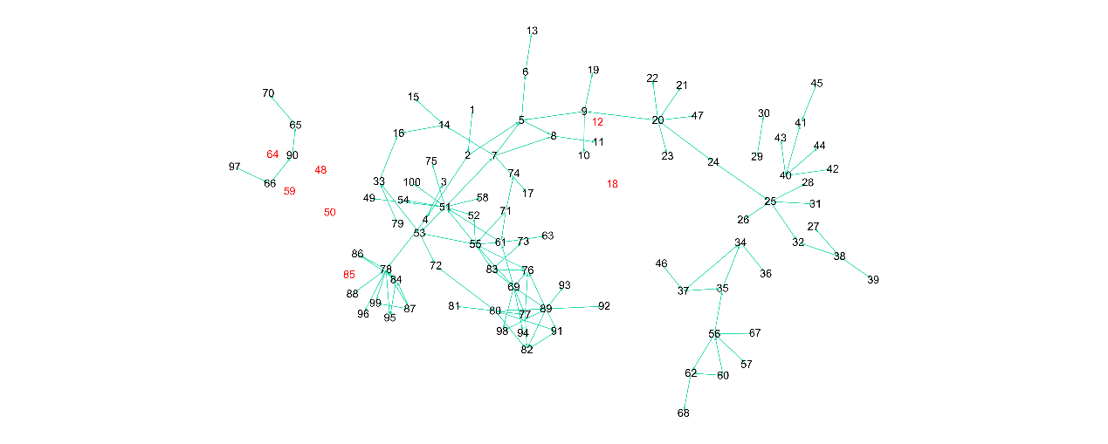

Figure S32. The rebuilt network of DREAM3_100_Yeast1.

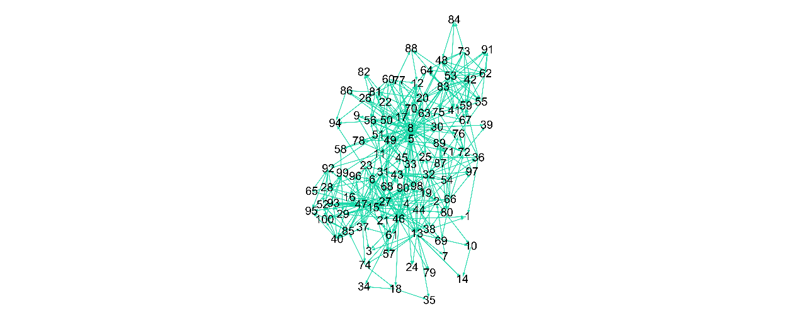

Figure S33. The standard network of DREAM3_100_Yeast2.

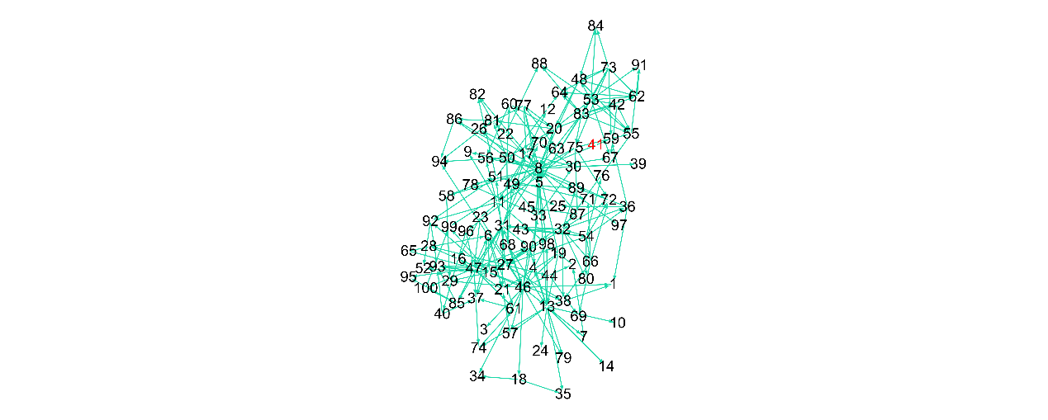

Figure S34. The rebuilt network of DREAM3_100_Yeast2.

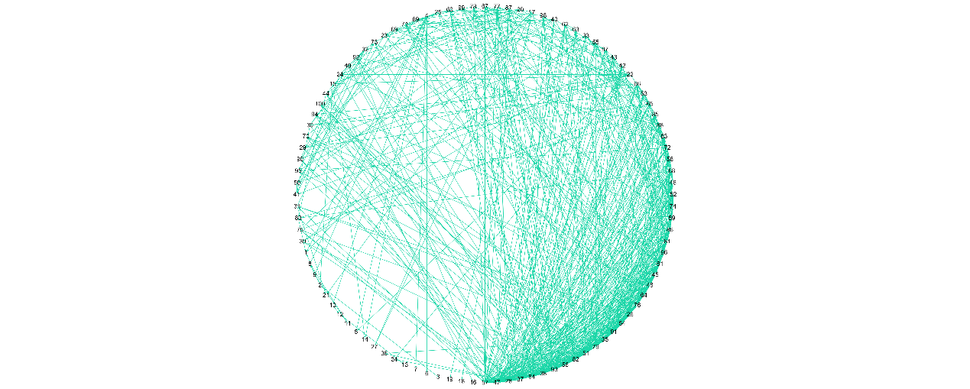

Figure S35. The standard network of DREAM3_100_Yeast3.

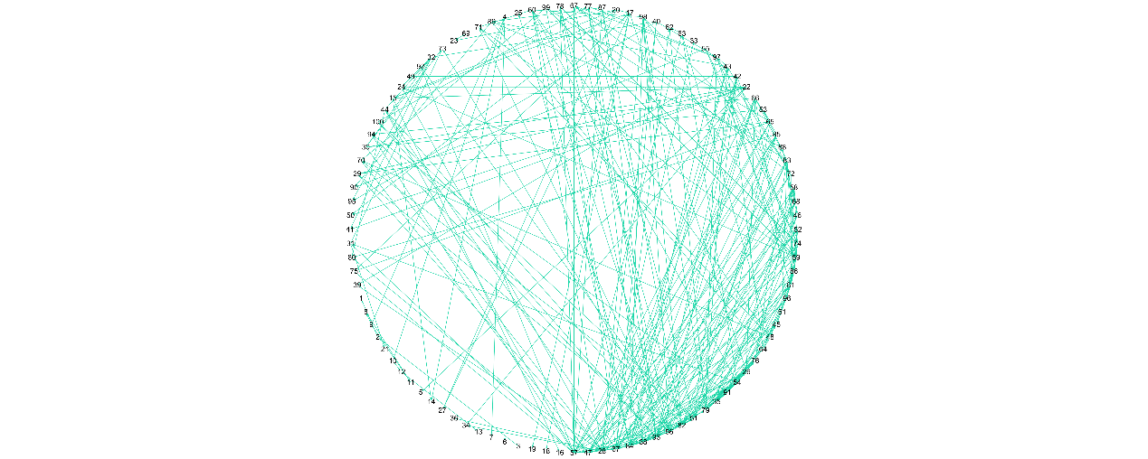

Figure S36. The rebuilt network of DREAM3_100_Yeast3.

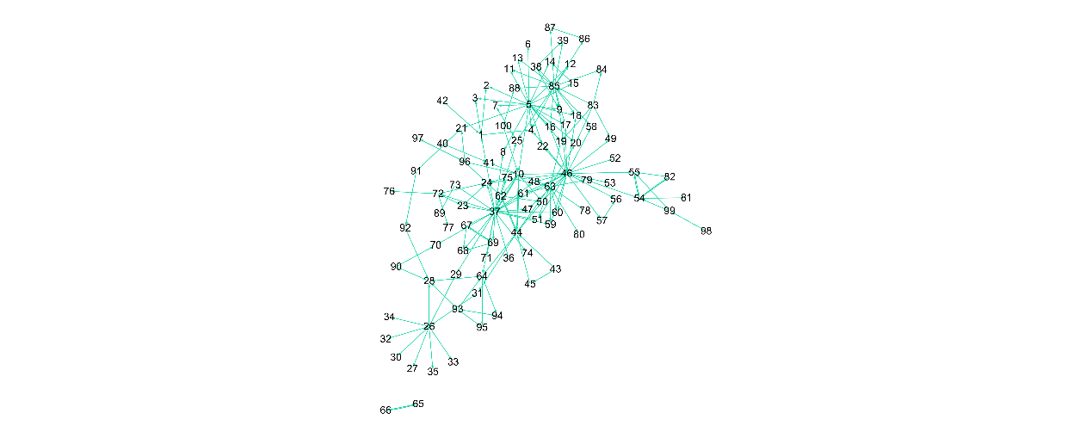

Figure S37. The standard network of Dream4_insilico_size100_1.

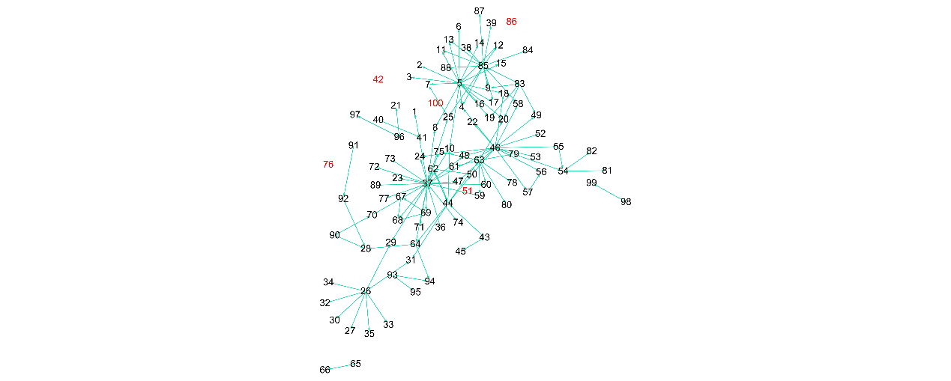

Figure S38. The rebuilt network of Dream4_insilico_size100_1.

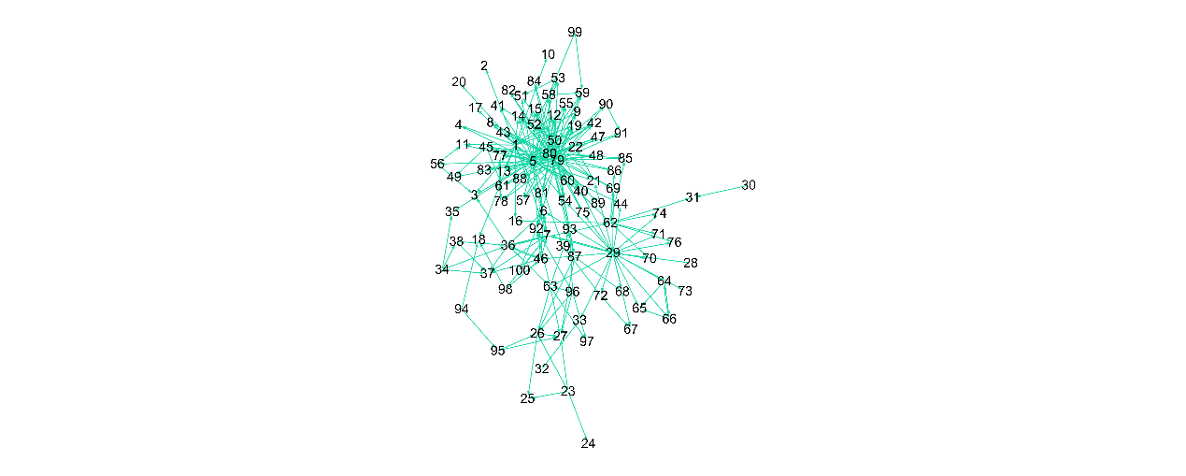

Figure S39. The standard network of Dream4_insilico_size100_2.

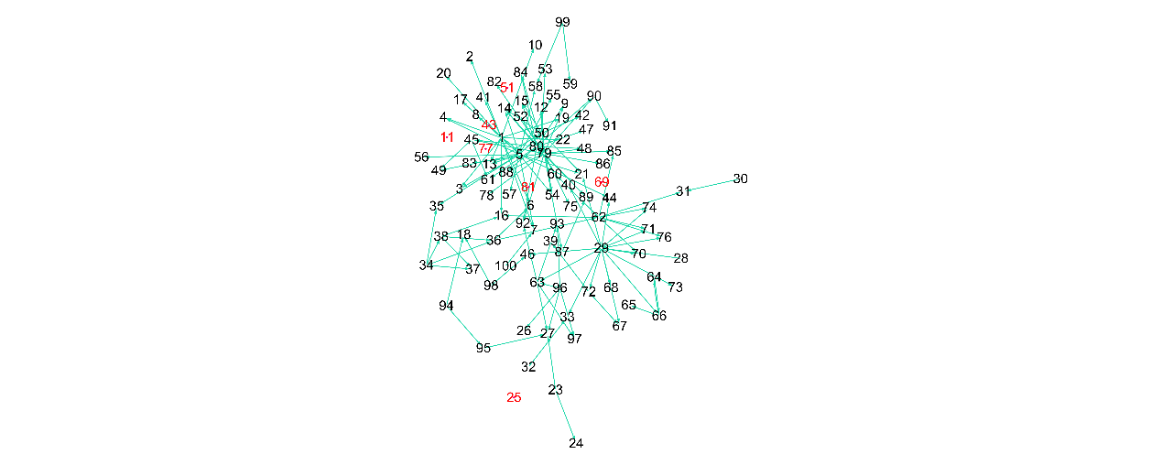

Figure S40. The rebuilt network of Dream4_insilico_size100_2.

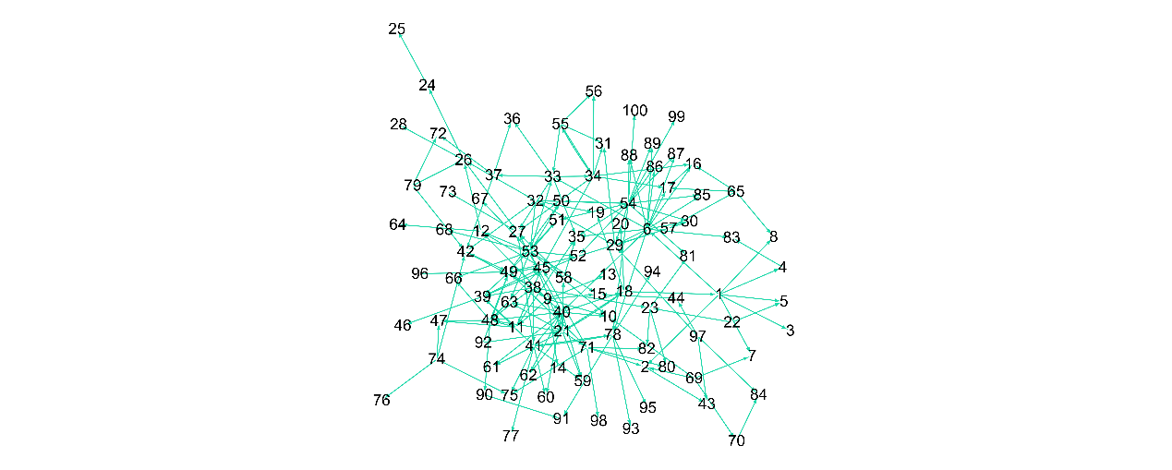

Figure S41. The standard network of Dream4_insilico_size100_3.

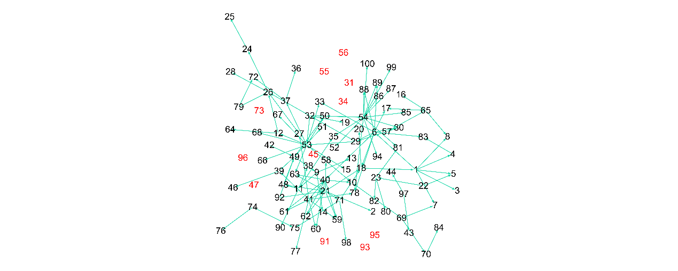

Figure S42. The rebuilt network of Dream4_insilico_size100_3.

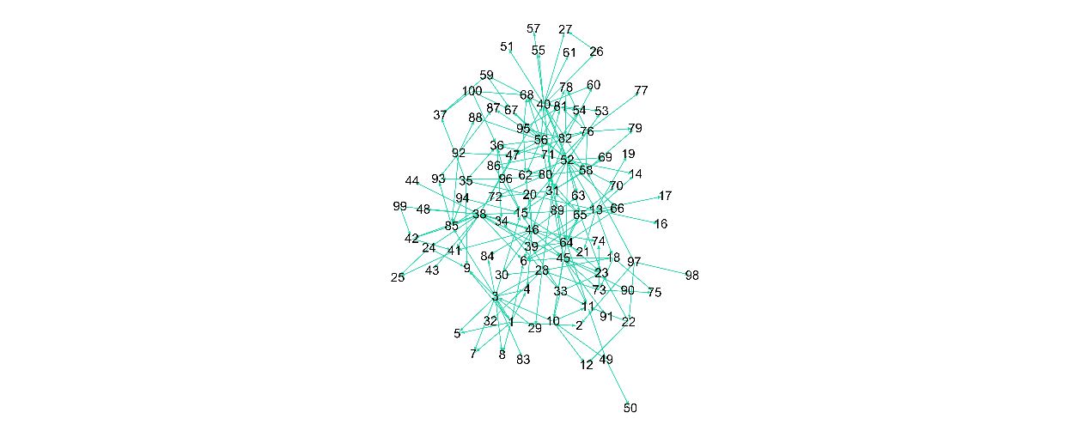

Figure S43. The standard network of Dream4_insilico_size100_4.

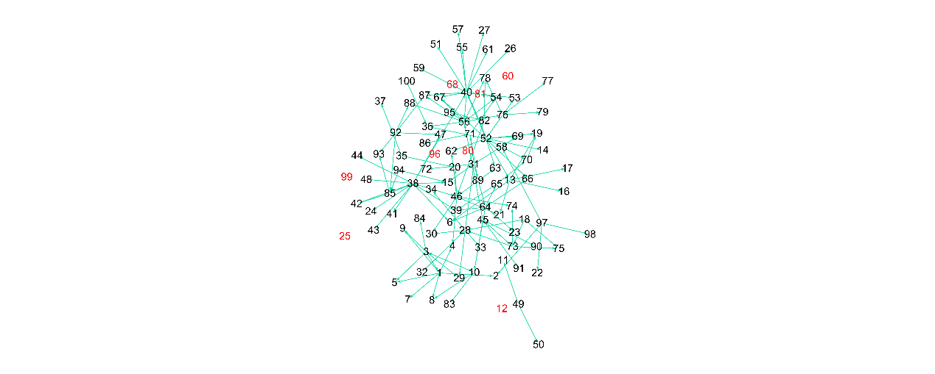

Figure S44. The rebuilt network of Dream4_insilico_size100_4.

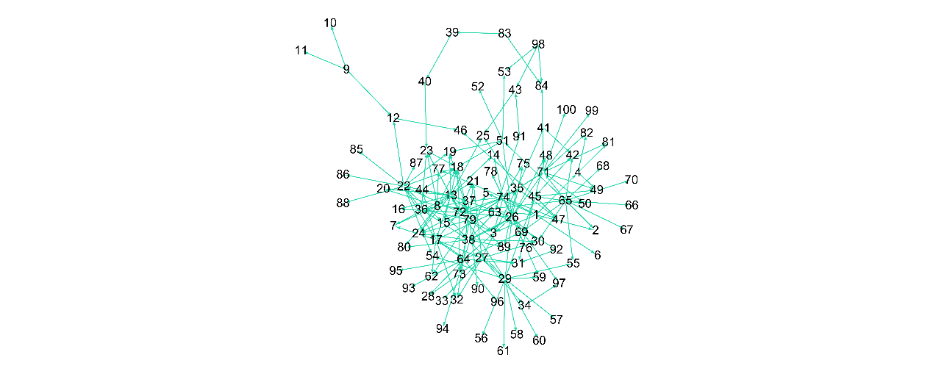

Figure S45. The standard network of Dream4_insilico_size100_5.

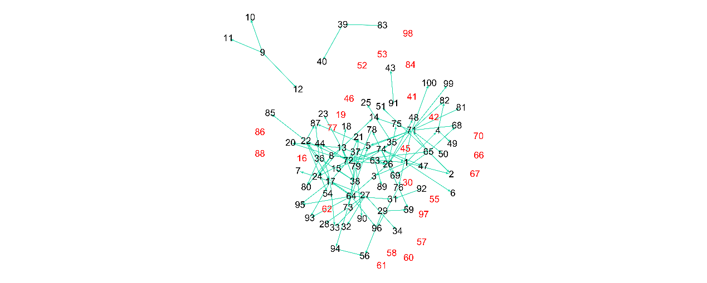

Figure S46. The rebuilt network of Dream4_insilico_size100_5.

1. **The relationship between the false negatives and the isolated genes or genes with low expression level**

We further investigated the false negative (FN) network to analyse whether or not FNs are related to isolated genes or genes with low expression levels. Herein, we consider a gene whose expression level in wild type is smaller than 0.3 as a low expression gene. The red node in the FN network represents the isolated or low expression gene, and the oriented edge in dark yellow represents a relation that is related to the isolated or low expression gene. According to Figures S50, S51, S56, S57, S59, S64, S65 and S66, there is a high correlation among them, but its robustness on all networks is still relatively weak, which could be considered as a future topic.

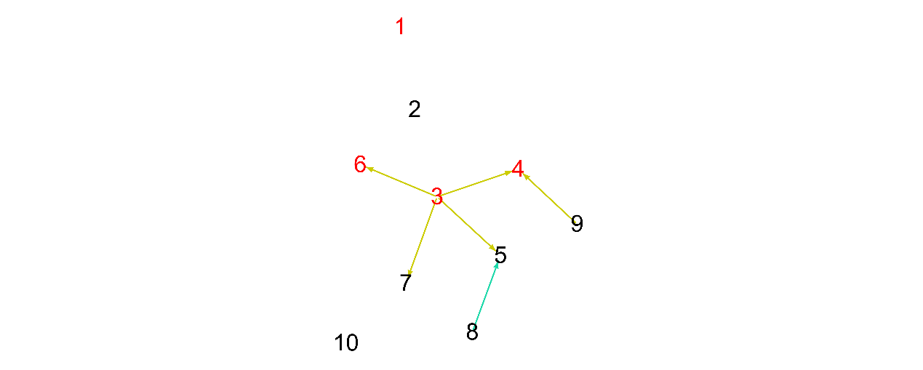

Figure S47. The false negative network of DREAM3_10_ Ecoli1.

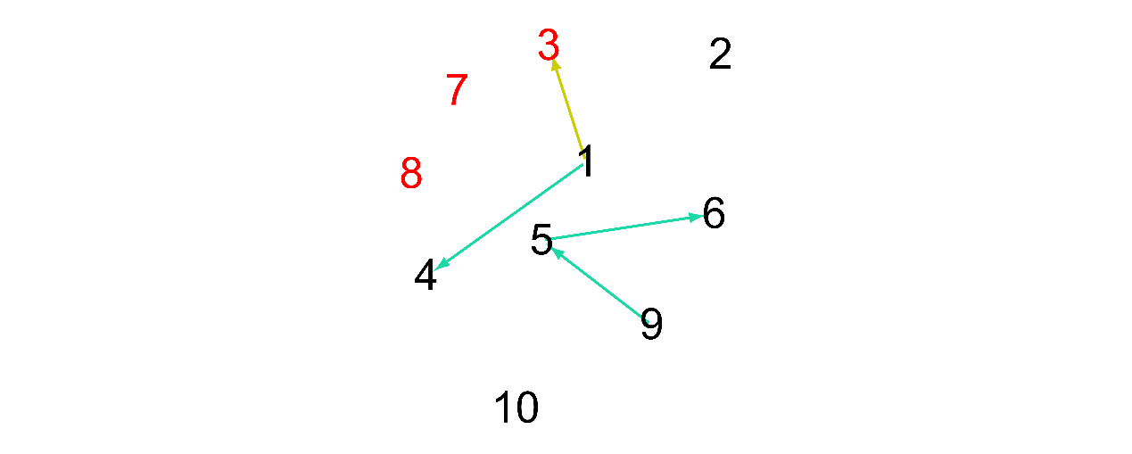

Figure S48. The false negative network of DREAM3_10_ Ecoli2.

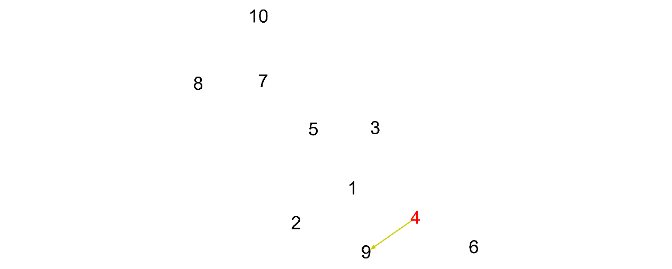

Figure S49. The false negative network of DREAM3_10_Yeast1.

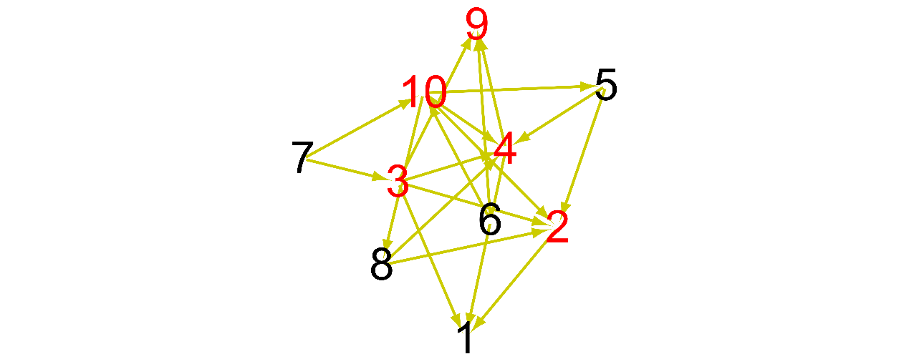

Figure S50. The false negative network of DREAM3_10_Yeast2.

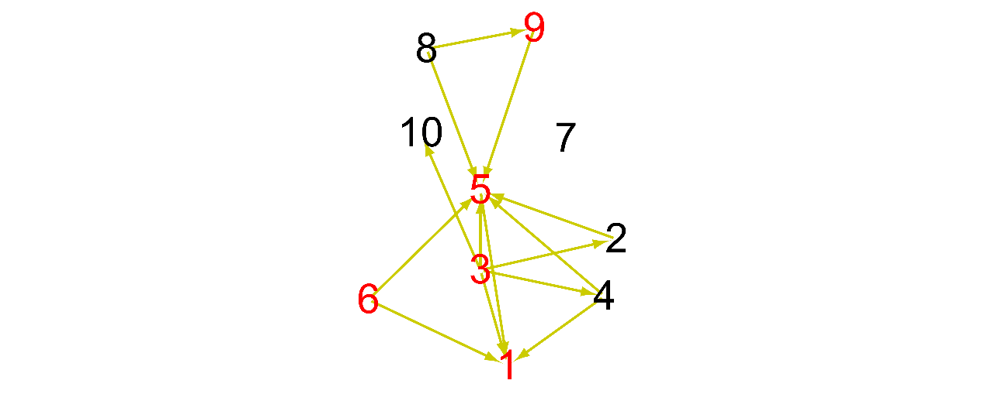

Figure S51. The false negative network of DREAM3_10_Yeast3.

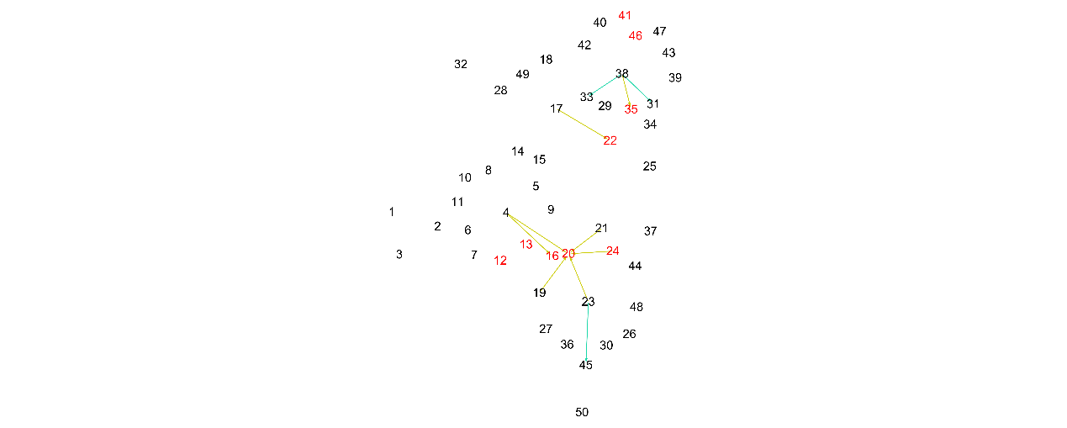

Figure S52. The false negative network of DREAM3_50_Ecoli1.

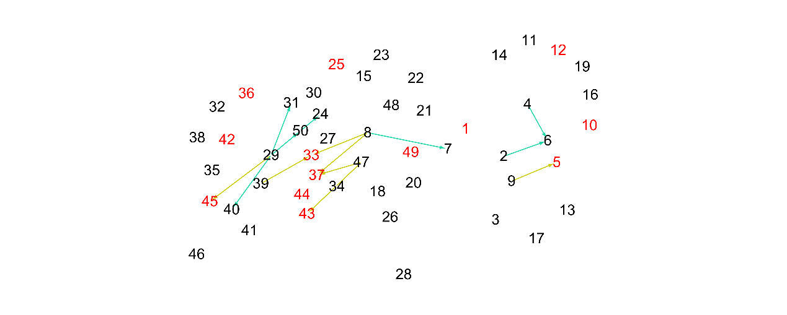

Figure S53. The false negative network of DREAM3_50_Ecoli2.

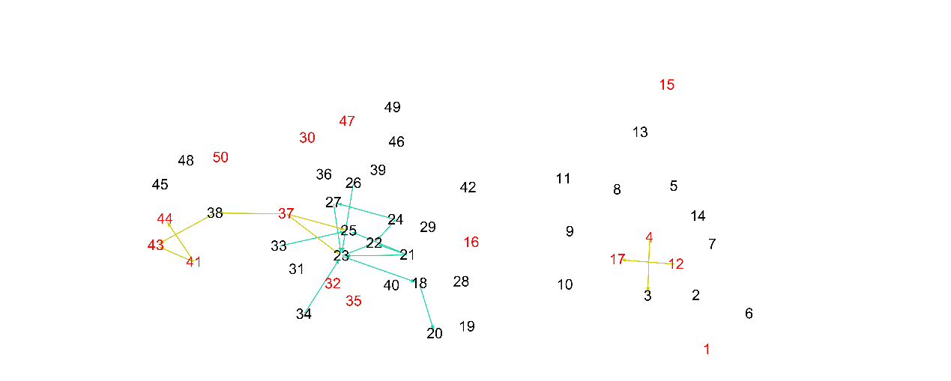

Figure S54. The false negative network of DREAM3_50_Yeast1.

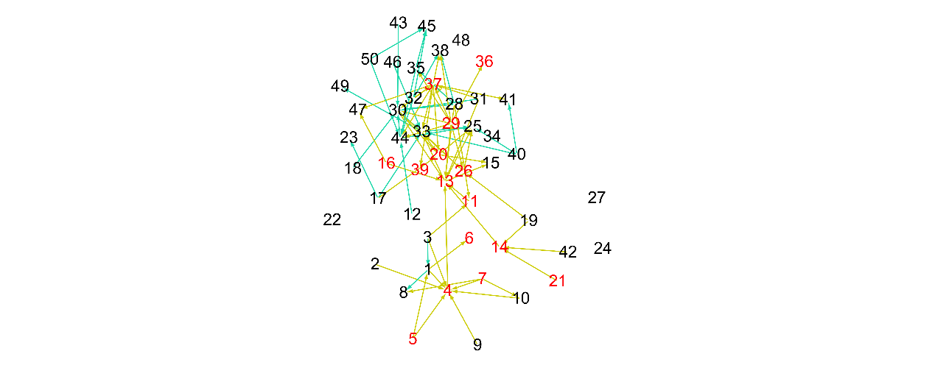

Figure S55. The false negative network of DREAM3_50_Yeast2.

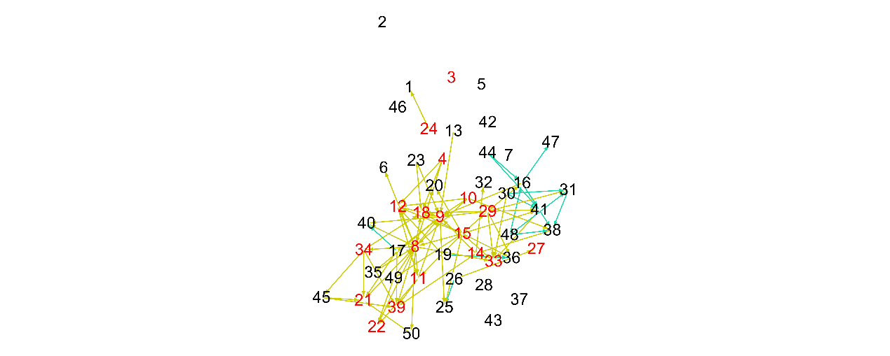

Figure S56. The false negative network of DREAM3_50_Yeast3.

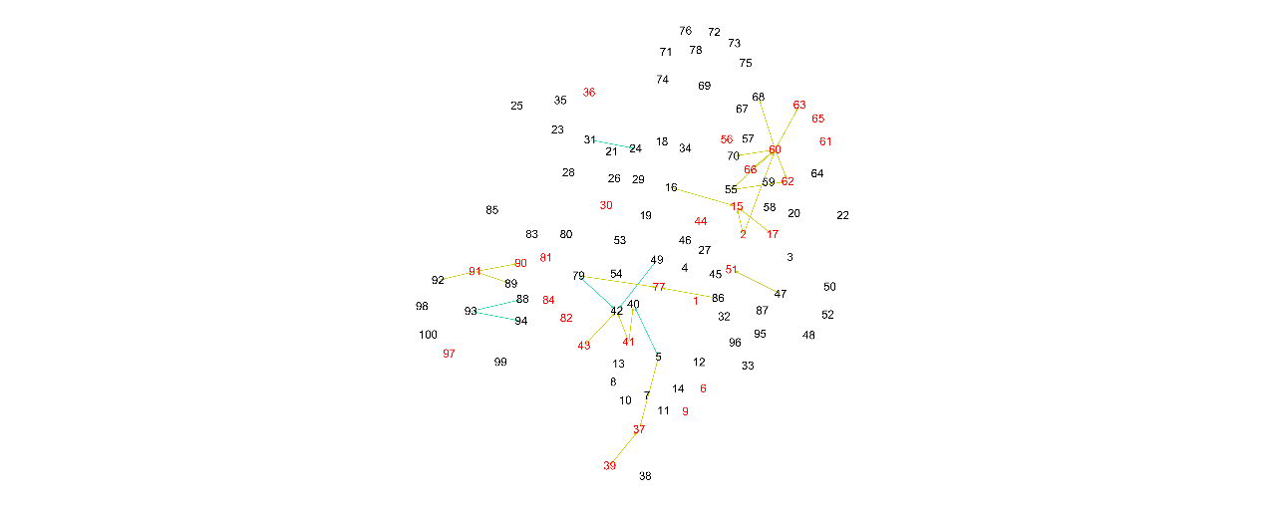

Figure S57. The false negative network of DREAM3_100_Ecoli1.

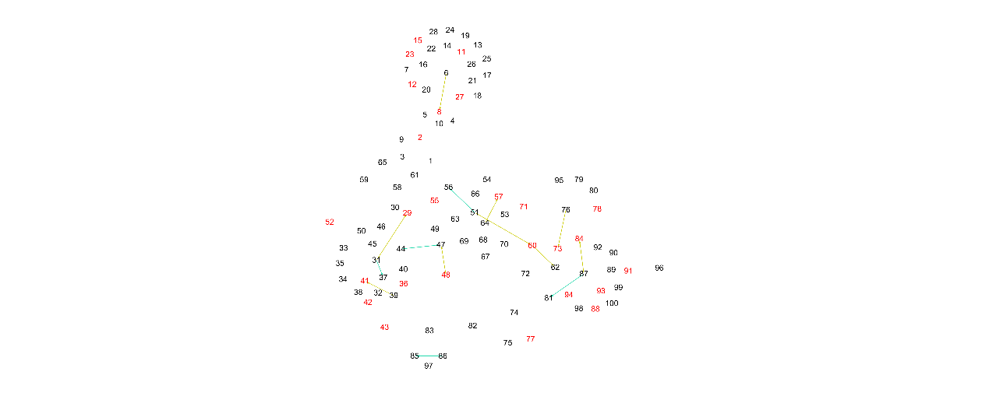

Figure S58. The false negative network of DREAM3_100_Ecoli2.

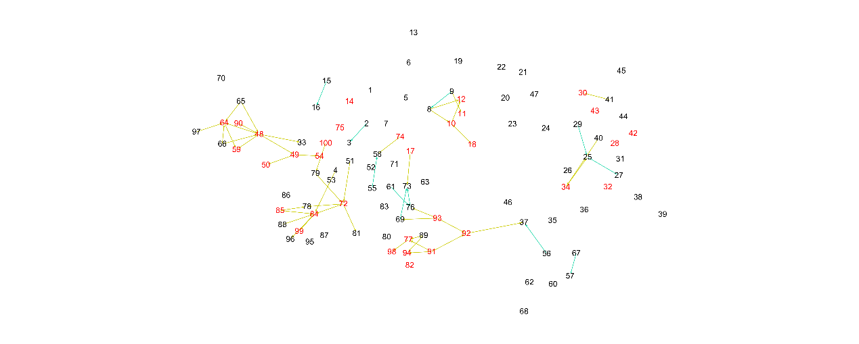

Figure S59. The false negative network of DREAM3_100_Yeast1.

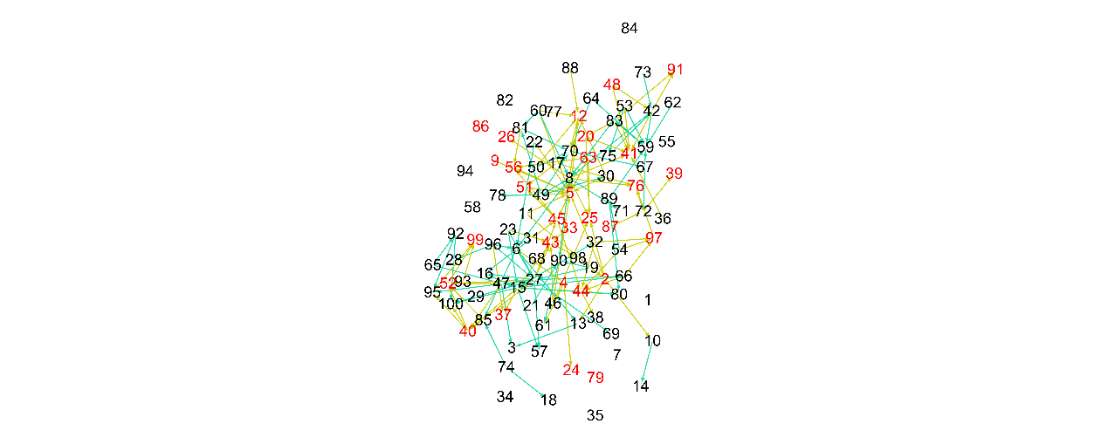

Figure S60. The false negative network of DREAM3_100_Yeast2.

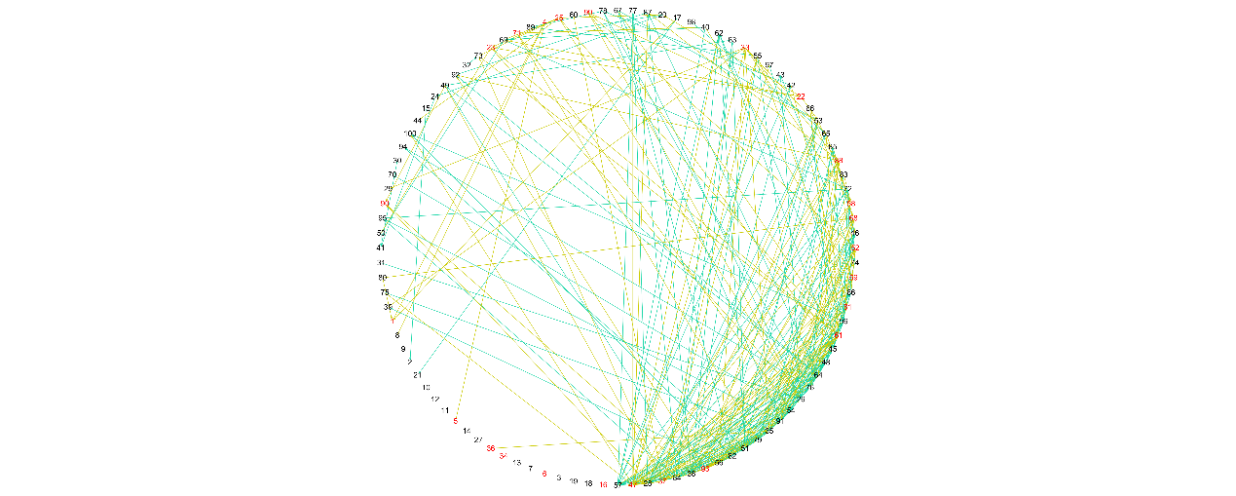

Figure S61. The false negative network of DREAM3_100_Yeast3.

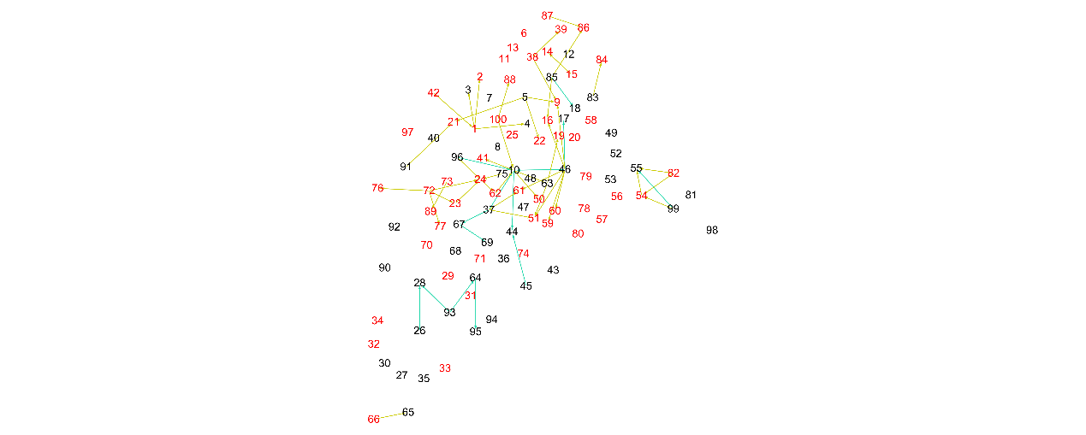

Figure S62. The false negative network of Dream4_insilico_size100_1.

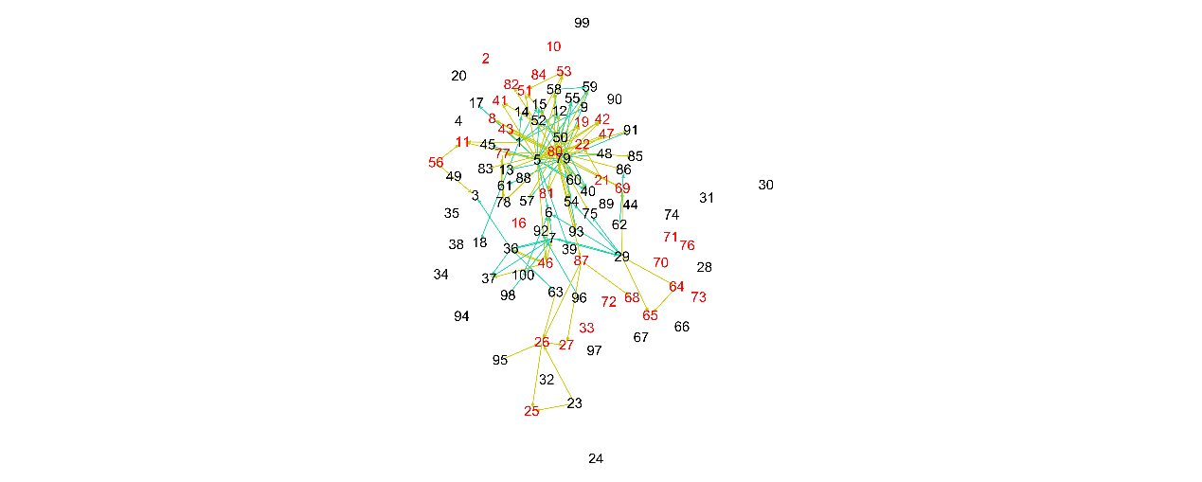

Figure S63. The false negative network of Dream4_insilico_size100_2.

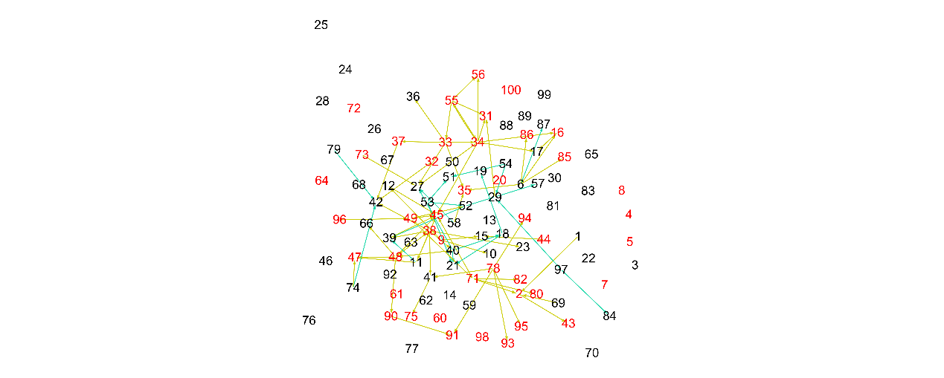

Figure S64. The false negative network of Dream4_insilico_size100_3.

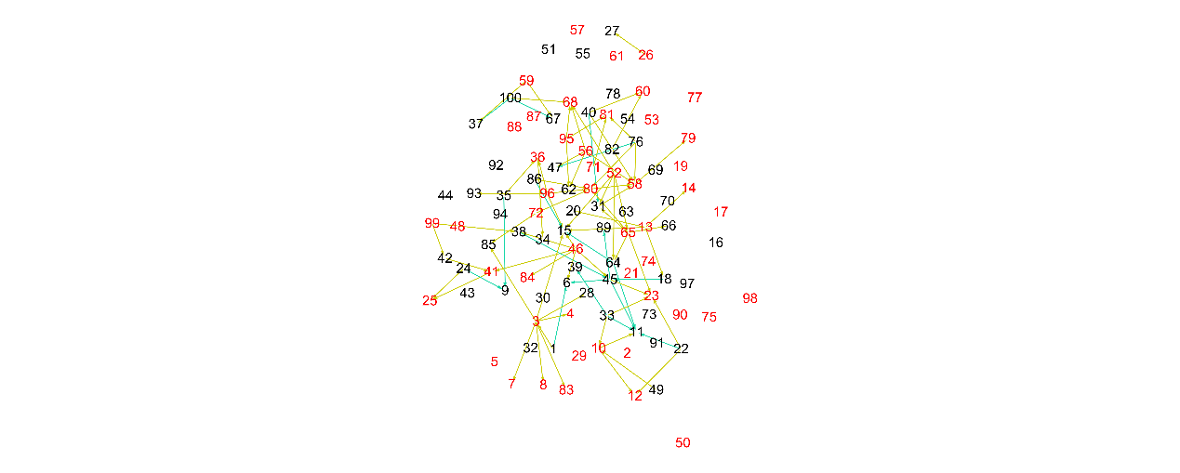

Figure S65. The false negative network of Dream4_insilico_size100_4.

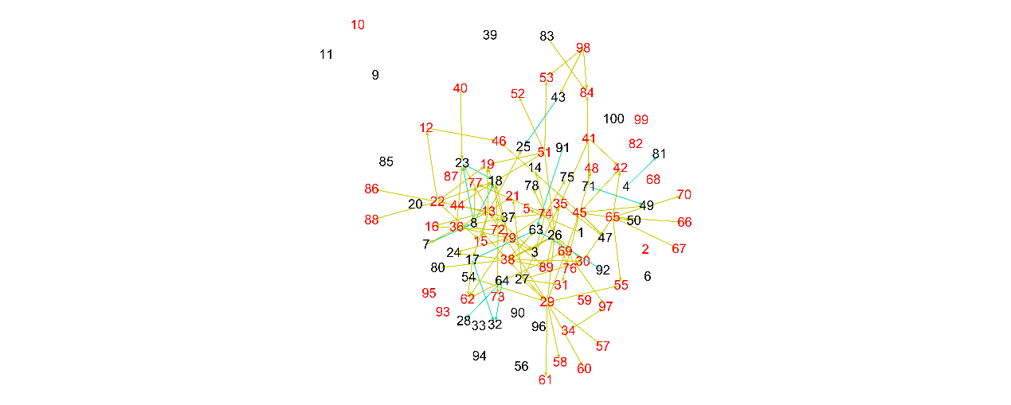

Figure S66. The false negative network of Dream4_insilico_size100_5.

Table S67. The comparison of methods in all metrices.

|  |  |  |  |  |  |  |  |  |  |  |  |  |
| --- | --- | --- | --- | --- | --- | --- | --- | --- | --- | --- | --- | --- |
| ***DS-ID*** | ***METHOD*** | ***TP*** | ***FP*** | ***TN*** | ***FN*** | ***TPR*** | ***FPR*** | ***PPV*** | ***ACC*** | ***MCC*** | ***BE*** | ***VR*** |
|  | PCA-CMI+ | 3.48 | 6.38 | 72.62 | 7.52 | 0.32 | 0.08 | 0.35 | 0.846 | 0.247 | 5.62 | 0.19 |
|  | PCA-PMI+ | 3.51 | 8.21 | 70.79 | 7.49 | 0.32 | 0.10 | 0.30 | 0.826 | 0.209 | 5 | 0.26 |
| **1** | CMI2NI+ | 3.41 | 10.25 | 68.75 | 7.59 | 0.31 | 0.13 | 0.25 | 0.802 | 0.165 | 5 | 0.23 |
|  | RWRNET+ | **\*6.25** | 10.36 | 68.64 | **\*4.75** | **\*0.57** | 0.13 | 0.38 | 0.832 | 0.369 | 5 | 0.18 |
|  | **FDENET** | 5 | **\*1** | **\*78** | 6 | 0.45 | **\*0.01** | **\*0.83** | **\*0.922** | **\*0.580** | **\*3** | **\*0.67** |
|  | PCA-CMI+ | 5.5 | 8.33 | 66.67 | 9.5 | 0.37 | 0.11 | 0.40 | 0.802 | 0.264 | **\*5** | 0.23 |
|  | PCA-PMI+ | 6.52 | 9.45 | 65.55 | 8.48 | 0.43 | 0.13 | 0.41 | 0.801 | 0.301 | **\*5** | 0.21 |
| **2** | CMI2NI+ | 5.45 | 8.34 | 66.66 | 9.55 | 0.36 | 0.11 | 0.39 | 0.801 | 0.261 | **\*5** | 0.22 |
|  | RWRNET+ | 7.44 | 11.39 | 63.61 | 7.56 | 0.50 | 0.15 | 0.39 | 0.789 | 0.315 | **\*5** | 0.21 |
|  | **FDENET** | **\*11** | **\*1** | **\*74** | **\*4** | **\*0.73** | **\*0.01** | **\*0.92** | **\*0.944** | **\*0.789** | 6 | **\*0.67** |
|  | PCA-CMI+ | 1.46 | 0.51 | 79.49 | 8.54 | 0.15 | 0.01 | 0.78 | 0.899 | 0.300 | 6 | 0.16 |
|  | PCA-PMI+ | 1.52 | 0.44 | 79.56 | 8.48 | 0.15 | 0.01 | 0.82 | 0.901 | 0.315 | 6 | 0.18 |
| **3** | CMI2NI+ | 1.47 | **\*0.41** | **\*79.59** | 8.53 | 0.15 | **\*0.01** | 0.82 | 0.901 | 0.312 | 6 | 0.18 |
|  | RWRNET+ | 8.13 | 12.67 | 67.33 | 1.87 | 0.81 | 0.16 | 0.39 | 0.838 | 0.488 | 6 | 0.24 |
|  | **FDENET** | **\*9** | 1 | 79 | **\*1** | **\*0.90** | 0.01 | **\*0.90** | **\*0.978** | **\*0.888** | **\*2** | **\*0.50** |
|  | PCA-CMI+ | 5.02 | 5.39 | 59.61 | 19.98 | 0.20 | 0.08 | 0.48 | 0.718 | 0.165 | 5.61 | 0.29 |
|  | PCA-PMI+ | 4.48 | 4.4 | 60.6 | 20.52 | 0.18 | 0.07 | 0.50 | 0.723 | 0.167 | 6 | 0.35 |
| **4** | CMI2NI+ | 5.25 | 5.34 | 59.66 | 19.75 | 0.21 | 0.08 | 0.49 | 0.721 | 0.178 | 5.66 | 0.33 |
|  | RWRNET+ | **\*7.15** | 13.64 | 51.36 | **\*17.85** | **\*0.29** | 0.21 | 0.34 | 0.650 | 0.081 | 6 | 0.42 |
|  | **FDENET** | 6 | **\*1** | **\*64** | 19 | 0.24 | **\*0.02** | **\*0.86** | **\*0.778** | **\*0.376** | **\*5** | **\*0.60** |
|  | PCA-CMI+ | 8.65 | 9.38 | 58.62 | 13.35 | 0.39 | 0.14 | 0.48 | 0.747 | 0.274 | 5 | 0.25 |
|  | PCA-PMI+ | 11.64 | 9.93 | 58.07 | 10.36 | 0.53 | 0.15 | 0.54 | 0.775 | 0.386 | 6 | 0.29 |
| **5** | CMI2NI+ | **\*12.62** | 14.96 | 53.04 | **\*9.38** | **\*0.57** | 0.22 | 0.46 | 0.730 | 0.330 | 6 | 0.28 |
|  | RWRNET+ | 6.88 | 9.3 | 58.7 | 15.12 | 0.31 | 0.14 | 0.42 | 0.729 | 0.197 | 5 | 0.32 |
|  | **FDENET** | 8 | **\*1** | **\*67** | 14 | 0.36 | **\*0.01** | **\*0.89** | **\*0.833** | **\*0.500** | **\*2** | **\*0.50** |
|  | PCA-CMI+ | 17.27 | 38.95 | 2349.05 | 44.73 | 0.28 | 0.02 | 0.31 | 0.966 | 0.275 | 123 | 0.04 |
|  | PCA-PMI+ | 20.21 | 28.13 | 2359.87 | 41.79 | 0.33 | 0.01 | 0.42 | 0.971 | 0.355 | 124 | 0.03 |
| **6** | CMI2NI+ | 18.47 | 37.84 | 2350.16 | 43.53 | 0.30 | 0.02 | 0.33 | 0.967 | 0.296 | 123 | 0.04 |
|  | RWRNET+ | 25.69 | 93.32 | 2294.68 | 36.31 | 0.41 | 0.04 | 0.22 | 0.947 | 0.274 | 125 | 0.06 |
|  | **FDENET** | **\*51** | **\*0** | **\*2388** | **\*11** | **\*0.82** | **\*0.00** | **\*1.00** | **\*0.996** | **\*0.905** | **\*41** | **\*0.46** |
|  | PCA-CMI+ | 14.74 | 47.72 | 2320.28 | 67.26 | 0.18 | 0.02 | 0.24 | 0.953 | 0.182 | 124 | 0.06 |
|  | PCA-PMI+ | 17.35 | 35.77 | 2332.23 | 64.65 | 0.21 | 0.02 | 0.33 | 0.959 | 0.243 | 123.41 | 0.05 |
| **7** | CMI2NI+ | 17.21 | 43.65 | 2324.35 | 64.79 | 0.21 | 0.02 | 0.28 | 0.956 | 0.221 | 123 | 0.05 |
|  | RWRNET+ | 24.88 | 60.17 | 2307.83 | 57.12 | 0.30 | 0.03 | 0.29 | 0.952 | 0.273 | 124 | 0.05 |
|  | **FDENET** | **\*68** | **\*0** | **\*2368** | **\*14** | **\*0.83** | **\*0.00** | **\*1.00** | **\*0.994** | **\*0.908** | **\*41** | **\*0.44** |
|  | PCA-CMI+ | 17.22 | 35.83 | 2337.17 | 59.78 | 0.22 | 0.02 | 0.32 | 0.961 | 0.250 | 123.4 | 0.04 |
|  | PCA-PMI+ | 20.23 | 35.08 | 2337.92 | 56.77 | 0.26 | 0.01 | 0.37 | 0.963 | 0.291 | 123 | 0.04 |
| **8** | CMI2NI+ | 19.18 | 35.87 | 2337.13 | 57.82 | 0.25 | 0.02 | 0.35 | 0.962 | 0.275 | 123 | 0.04 |
|  | RWRNET+ | 29.77 | 81.41 | 2291.59 | 47.23 | 0.39 | 0.03 | 0.27 | 0.947 | 0.295 | 124 | 0.06 |
|  | **FDENET** | **\*57** | **\*3** | **\*2370** | **\*20** | **\*0.74** | **\*0.00** | **\*0.95** | **\*0.991** | **\*0.834** | **\*75** | **\*0.36** |
|  | PCA-CMI+ | 22 | 37.01 | 2252.99 | 138 | 0.14 | 0.02 | 0.37 | 0.929 | 0.196 | 123 | 0.07 |
|  | PCA-PMI+ | 22.69 | 26.08 | 2263.92 | 137.31 | 0.14 | 0.01 | 0.46 | 0.933 | 0.231 | 124 | 0.07 |
| **9** | CMI2NI+ | 23.1 | 33.87 | 2256.13 | 136.9 | 0.14 | 0.01 | 0.40 | 0.930 | 0.212 | 123.32 | 0.07 |
|  | RWRNET+ | 33.76 | 62.51 | 2227.49 | 126.24 | 0.21 | 0.03 | 0.35 | 0.923 | 0.234 | 124 | 0.08 |
|  | **FDENET** | **\*78** | **\*5** | **\*2285** | **\*82** | **\*0.49** | **\*0.00** | **\*0.94** | **\*0.964** | **\*0.663** | **\*96** | **\*0.41** |
|  | PCA-CMI+ | 22.61 | 31.03 | 2245.97 | 150.39 | 0.13 | 0.01 | 0.42 | 0.926 | 0.205 | 124 | 0.08 |
|  | PCA-PMI+ | 20.77 | 23.68 | 2253.32 | 152.23 | 0.12 | 0.01 | 0.47 | 0.928 | 0.210 | **\*123** | 0.07 |
| **10** | CMI2NI+ | 23.01 | 31.01 | 2245.99 | 149.99 | 0.13 | 0.01 | 0.42 | 0.926 | 0.208 | 124 | 0.08 |
|  | RWRNET+ | 27.54 | 62.1 | 2214.9 | 145.46 | 0.16 | 0.03 | 0.31 | 0.915 | 0.180 | 124 | 0.09 |
|  | **FDENET** | **\*87** | **\*6** | **\*2271** | **\*86** | **\*0.50** | **\*0.00** | **\*0.94** | **\*0.962** | **\*0.671** | 128 | **\*0.47** |
|  | PCA-CMI+ | 24.69 | 50.16 | 9724.84 | 100.31 | 0.20 | 0.01 | 0.33 | 0.985 | 0.248 | 496 | 0.02 |
|  | PCA-PMI+ | 23.57 | 32.1 | 9742.9 | 101.43 | 0.19 | 0.00 | 0.42 | 0.987 | 0.277 | 496 | 0.02 |
| **11** | CMI2NI+ | 21.34 | 46.97 | 9728.03 | 103.66 | 0.17 | 0.00 | 0.31 | 0.985 | 0.224 | 496 | 0.02 |
|  | RWRNET+ | 50.12 | 137.37 | 9637.63 | 74.88 | 0.40 | 0.01 | 0.27 | 0.979 | 0.317 | 497 | 0.02 |
|  | **FDENET** | **\*97** | **\*2** | **\*9773** | **\*28** | **\*0.78** | **\*0.00** | **\*0.98** | **\*0.997** | **\*0.871** | **\*91** | **\*0.31** |
|  | PCA-CMI+ | 25.93 | 94.03 | 9686.97 | 93.07 | 0.22 | 0.01 | 0.22 | 0.981 | 0.207 | 496 | 0.02 |
|  | PCA-PMI+ | 25.92 | 75.02 | 9705.98 | 93.08 | 0.22 | 0.01 | 0.26 | 0.983 | 0.228 | 496 | 0.02 |
| **12** | CMI2NI+ | 25.99 | 84.2 | 9696.8 | 93.01 | 0.22 | 0.01 | 0.24 | 0.982 | 0.218 | 496 | 0.02 |
|  | RWRNET+ | 40.89 | 147.13 | 9633.87 | 78.11 | 0.34 | 0.02 | 0.22 | 0.977 | 0.262 | 497 | 0.02 |
|  | **FDENET** | **\*105** | **\*0** | **\*9781** | **\*14** | **\*0.88** | **\*0.00** | **\*1.00** | **\*0.999** | **\*0.939** | **\*83** | **\*0.36** |
|  | PCA-CMI+ | 25.71 | 44.06 | 9689.94 | 140.29 | 0.15 | 0.00 | 0.37 | 0.981 | 0.231 | 496 | 0.02 |
|  | PCA-PMI+ | 27.22 | 33.94 | 9700.06 | 138.78 | 0.16 | 0.00 | 0.44 | 0.983 | 0.263 | 496 | 0.02 |
| **13** | CMI2NI+ | 27.19 | 43.15 | 9690.85 | 138.81 | 0.16 | 0.00 | 0.39 | 0.982 | 0.244 | 496 | 0.02 |
|  | RWRNET+ | 61.52 | 133.07 | 9600.93 | 104.48 | 0.37 | 0.01 | 0.32 | 0.976 | 0.330 | 496.99 | 0.03 |
|  | **FDENET** | **\*110** | **\*3** | **\*9731** | **\*56** | **\*0.66** | **\*0.00** | **\*0.97** | **\*0.994** | **\*0.801** | **\*173** | **\*0.32** |
|  | PCA-CMI+ | 43.49 | 33.31 | 9477.69 | 345.51 | 0.11 | 0.00 | 0.57 | 0.962 | 0.240 | 495.95 | 0.04 |
|  | PCA-PMI+ | 43.31 | 27.32 | 9483.68 | 345.69 | 0.11 | 0.00 | 0.61 | 0.962 | 0.250 | 496 | 0.04 |
| **14** | CMI2NI+ | 43.16 | 33.19 | 9477.81 | 345.84 | 0.11 | 0.00 | 0.56 | 0.962 | 0.239 | 495.97 | 0.04 |
|  | RWRNET+ | 72.03 | 103.08 | 9407.92 | 316.97 | 0.19 | 0.01 | 0.41 | 0.958 | 0.257 | 497 | 0.04 |
|  | **FDENET** | **\*239** | **\*1** | **\*9510** | **\*150** | **\*0.61** | **\*0.00** | **\*1.00** | **\*0.985** | **\*0.776** | **\*379** | **\*0.41** |
|  | PCA-CMI+ | 42.84 | 25.97 | 9323.03 | 508.16 | 0.08 | 0.00 | 0.62 | 0.946 | 0.207 | 496 | 0.06 |
|  | PCA-PMI+ | 42.43 | 23.69 | 9325.31 | 508.57 | 0.08 | 0.00 | 0.64 | 0.946 | 0.210 | 495.9 | 0.06 |
| **15** | CMI2NI+ | 42.4 | 26.13 | 9322.87 | 508.6 | 0.08 | 0.00 | 0.62 | 0.946 | 0.205 | 496 | 0.06 |
|  | RWRNET+ | 76.67 | 115.75 | 9233.25 | 474.33 | 0.14 | 0.01 | 0.40 | 0.940 | 0.211 | 497 | 0.06 |
|  | **FDENET** | **\*273** | **\*0** | **\*9349** | **\*278** | **\*0.50** | **\*0.00** | **\*1.00** | **\*0.972** | **\*0.694** | **\*429** | **\*0.41** |
|  | PCA-CMI+ | 29.72 | 146.17 | 9577.83 | 146.28 | 0.17 | 0.02 | 0.17 | 0.970 | 0.154 | 496 | 0.03 |
|  | PCA-PMI+ | 24.07 | 99.81 | 9624.19 | 151.93 | 0.14 | 0.01 | 0.19 | 0.975 | 0.150 | 497 | 0.03 |
| **16** | CMI2NI+ | 33.4 | 149.32 | 9574.68 | 142.6 | 0.19 | 0.02 | 0.18 | 0.971 | 0.171 | 497 | 0.03 |
|  | RWRNET+ | 36.56 | 133.34 | 9590.66 | 139.44 | 0.21 | 0.01 | 0.21 | 0.972 | 0.197 | 497 | 0.03 |
|  | **FDENET** | **\*119** | **\*3** | **\*9721** | **\*57** | **\*0.68** | **\*0.00** | **\*0.98** | **\*0.994** | **\*0.809** | **\*230** | **\*0.50** |
|  | PCA-CMI+ | 21.05 | 29.37 | 9621.63 | 227.95 | 0.08 | 0.00 | 0.42 | 0.974 | 0.179 | 495.94 | 0.03 |
|  | PCA-PMI+ | 23.21 | 27.53 | 9623.47 | 225.79 | 0.09 | 0.00 | 0.46 | 0.974 | 0.198 | 495.96 | 0.03 |
| **17** | CMI2NI+ | 20.82 | 29.46 | 9621.54 | 228.18 | 0.08 | 0.00 | 0.41 | 0.974 | 0.177 | 495.98 | 0.03 |
|  | RWRNET+ | 46.75 | 155.67 | 9495.33 | 202.25 | 0.19 | 0.02 | 0.23 | 0.964 | 0.190 | 496 | 0.04 |
|  | **FDENET** | **\*129** | **\*5** | **\*9646** | **\*120** | **\*0.52** | **\*0.00** | **\*0.96** | **\*0.987** | **\*0.701** | **\*251** | **\*0.39** |
|  | PCA-CMI+ | 31.96 | 50.19 | 9654.81 | 163.04 | 0.16 | 0.01 | 0.39 | 0.978 | 0.243 | 496 | 0.02 |
|  | PCA-PMI+ | 28.62 | 37.98 | 9667.02 | 166.38 | 0.15 | 0.00 | 0.43 | 0.979 | 0.243 | 495.97 | 0.02 |
| **18** | CMI2NI+ | 31.6 | 48.41 | 9656.59 | 163.4 | 0.16 | 0.00 | 0.39 | 0.979 | 0.244 | 496 | 0.02 |
|  | RWRNET+ | 46.58 | 128.9 | 9576.1 | 148.42 | 0.24 | 0.01 | 0.27 | 0.972 | 0.238 | 497 | 0.03 |
|  | **FDENET** | **\*111** | **\*8** | **\*9697** | **\*84** | **\*0.57** | **\*0.00** | **\*0.93** | **\*0.991** | **\*0.725** | **\*294** | **\*0.41** |
|  | PCA-CMI+ | 25.97 | 69.92 | 9619.08 | 185.03 | 0.12 | 0.01 | 0.27 | 0.974 | 0.171 | 496 | 0.03 |
|  | PCA-PMI+ | 25.09 | 53.88 | 9635.12 | 185.91 | 0.12 | 0.01 | 0.32 | 0.976 | 0.184 | 496 | 0.03 |
| **19** | CMI2NI+ | 25.47 | 65.81 | 9623.19 | 185.53 | 0.12 | 0.01 | 0.28 | 0.975 | 0.172 | 496 | 0.03 |
|  | RWRNET+ | 40.84 | 124.83 | 9564.17 | 170.16 | 0.19 | 0.01 | 0.25 | 0.970 | 0.203 | 497 | 0.03 |
|  | **FDENET** | **\*123** | **\*7** | **\*9682** | **\*88** | **\*0.58** | **\*0.00** | **\*0.95** | **\*0.990** | **\*0.739** | **\*327** | **\*0.50** |
|  | PCA-CMI+ | 26.7 | 119.05 | 9587.95 | 166.3 | 0.14 | 0.01 | 0.18 | 0.971 | 0.145 | 496.99 | 0.03 |
|  | PCA-PMI+ | 25.81 | 67.03 | 9639.97 | 167.19 | 0.13 | 0.01 | 0.28 | 0.976 | 0.182 | 496 | 0.03 |
| **20** | CMI2NI+ | 31.6 | 137.14 | 9569.86 | 161.4 | 0.16 | 0.01 | 0.19 | 0.970 | 0.160 | 496.3 | 0.03 |
|  | RWRNET+ | 29.02 | 147.96 | 9559.04 | 163.98 | 0.15 | 0.02 | 0.16 | 0.968 | 0.141 | 496.99 | 0.03 |
|  | **FDENET** | **\*82** | **\*19** | **\*9688** | **\*111** | **\*0.42** | **\*0.00** | **\*0.81** | **\*0.987** | **\*0.582** | **\*365** | **\*0.62** |